Technical requirements specification for EURO_IT4I system

Contracting Authority’s Intention
The contracting authority intends to modernize and increase the performance of the IT4Innovations National Supercomputing Center (hereinafter referred to as IT4Innovations) computing infrastructure operated by the contracting authority.

Purpose of the “EURO_IT4I system” public procurement is to implement a new supercomputer – EURO_IT4I system – that will replace the current Salomon supercomputer.

EURO_IT4I system will be operated by the IT4Innovations National Supercomputing Center and will be used to provide services in the field of High Performance Computing.

EURO_IT4I system will be installed and operated in the contracting authority’s data center located in the IT4Innovations building, at the Technical University of Ostrava.

Subject of the Procurement
The subject of the “EURO_IT4I Supercomputer” public procurement is the delivery of a comprehensive High Performance Computing system, i.e. a complex of computing, storage, network, and other systems and software solution, including implementation and integration into the contracting authority’s data center, training, warranty, support, and other services.

Document Structure
The following labels are shown in the following text:
SPEC_Nr. indicates individual requirements of the procurement for easier identification.
SPEC_Nr. (I) indicates that additional information is required. The supplier must state this information in their offer.

EURO_IT4I System
- The contracting authority requires a comprehensive computing system solution designed for HPC, i.e. a complex of computing, storage, network, and other systems and software solution, including implementation and integration into the contracting authority’s data center (hereinafter referred to as the solution or EURO_IT4I system).

- EURO_IT4I system must allow effective execution of a large number of simultaneous computing jobs of all phases of the job life cycle (i.e. preparation, pre-processing, computing, post-processing) of various types (especially parallel, but also serial, batch, and interactive) of large number of users. EURO_IT4I system must allow secure and reliable user data storage, fast access to data, and effective administration of systems, components, resources and services.

- EURO_IT4I system must offer powerful computing resources, which are easily accessible by users and their jobs. The solution must provide features, services, and functions required for effective system operation and administration by the contracting authority. The solution must be balanced and parameters and structure of individual subsystems must consider other subsystems.

- EURO_IT4I system delivery must include all systems, equipment, accessories, licenses, documentation, design, implementation, and other work, training, etc. necessary to meet the contracting authority’s requirements.

- The solution must consider disposition and limitations resulting from the environment and conditions of the contracting authority’s data center.

- The solution must not contain any limitations preventing or restricting the operation of EURO_IT4I system by the contracting authority in required, expected, or rational scope. EURO_IT4I system is intended for approximately 3,000 users.

- The solution as a whole must completely fulfill the contracting authority’s requirements. Required functionality and features must be realistically functional and usable in operation of the solution; required parameters must be realistically achievable. Fulfilment of the contracting authority’s requirements must not be conditioned.
The fulfillment of the contracting authority's requirements must not be based solely on functionality, properties, or parameters of individual components.

- The functionality, features, and parameters of the solution must be stated for the proposed/delivered configuration designed for everyday use. The functionality, properties, and parameters must not be conditioned

- The solution must meet all contracting authority’s technical requirements simultaneously. All required features, functions, and parameters must be achieved using a single production setup of all the components in the solution. Fulfillment of the requirements must not be conditioned on changing the setup or interconnection of the components.

- To the maximum extent possible, the solution must be autonomous, independent of external systems and services, and self-sufficient without the need for additional equipment, systems, or services.

- Design and implementation of the solution must ensure reliable, secure, powerful, and efficient operation of EURO_IT4I system in the contracting authority’s data center.

EURO_IT4I System Components
- EURO_IT4I system must include a Compute cluster. A Compute cluster consists of Compute nodes connected by a Compute network — a high-speed, low latency network. A Compute cluster is designed for computing users’ jobs.

- The Compute cluster must contain four partitions:
- Universal compute partition
- Accelerated compute partition
- Data analytics compute partition
- Cloud infrastructure compute partition

- The Universal compute partition must consist of standard servers without accelerators such as GPUs or FPGAs and should be based on x86 CPU architecture to provide quick accessibility for the users and their existing codes.

- The Accelerated compute partition should deliver most of the compute power usable for HPC but also excellent performance in HPDA and AI workloads, especially in the learning phase of Deep Neural Networks. The Accelerated compute partition should consist of heavily GPU-accelerated nodes.

- The Data analytics compute partition should be oriented on supporting huge memory jobs by implementing a NUMA SMP system with large cache coherent memory.

- The Cloud infrastructure compute partition should support both the research and operation of the Infrastructure/HPC as a Service. The Cloud infrastructure compute partition is intended for provision and operation of cloud technologies like OpenStack and Kubernetes.

- EURO_IT4I system must include Login nodes – nodes for user access, job and data preparation, code compilation and debugging, result processing, and data transfer.

- EURO_IT4I system must include Visualization nodes – nodes for remote visualization and user data modeling using hardware-accelerated graphics applications.

- EURO_IT4I system must include data storages called Storages. Storages are designed for storing and sharing data. Storages are a comprehensive solution of storage devices, I/O servers (e.g. file servers), network, and necessary software. The storages must provide required data services.

- EURO_IT4I system must include HOME storage. HOME storage is a file storage designed for storing users’ operating system settings and users’ applications on the supercomputer.

- EURO_IT4I system must include SCRATCH storage. SCRATCH storage is a powerful file storage designed for short-term users’ job data. Compute nodes use SCRATCH storage intensively.

- EURO_IT4I system must include INFRA storage. INFRA Storage is a file storage designed for storing and sharing infrastructure data of the supercomputer. The storage is used for storing system images of nodes, logs, infrastructure service data, application software, scheduler data, etc.

- EURO_IT4I system must include PROJECT Network Gateways. PROJECT Network Gateways are servers intended for connecting EURO_IT4I system with PROJECT data storage to allow access to PROJECT data storage. PROJECT data storage is the contracting authority’s external storage designed for multi-year user project data and sharing of the data between IT4Innovations supercomputers.

- EURO_IT4I system must include Data management nodes. Data management nodes are designed for data transfer between storages and are used primarily to transfer data from/to supercomputer via parallel transfers to relieve the load on Login nodes. The nodes also serve to directly access the storages from external locations (Internet) by the users.

- EURO_IT4I system must include infrastructure and management nodes (hereinafter referred to as Infrastructure nodes). Infrastructure nodes are designed to provide infrastructure services to EURO_IT4I system (e.g. DHCP, DNS, LDAP, provisioning, license servers, schedulers, monitoring, logging, etc.) and for management and administration of the supercomputer, resources, and services.

- EURO_IT4I system must include a data Backup solution.

- EURO_IT4I system must include Network infrastructure, i.e. a network connection of the components and systems to achieve required functionality, provide access to individual services, and provide performance, availability, and security of the services.

- The network infrastructure consists of cluster Compute network, LAN, other networks, as designed by the supplier, and integration into contracting authority’s WAN.
Compute network connects Compute nodes of the compute cluster, Login nodes, Visualization nodes, Data management nodes, and other servers.
LAN provides communication between components inside the supercomputer.
Integration into WAN network of the contracting authority provides connection to contracting authority’s WAN network and Internet connectivity for the supercomputer.

- EURO_IT4I system must include the solution and infrastructure for installation and operation of the supercomputer in the contracting authority’s data center (hereinafter referred to as Infrastructure for operation in data center). This includes racks and accessories required for placement of the supercomputer, the solution for power supply, and cooling of the supercomputer, systems, interfaces, and connections to the infrastructure of contracting authority’s data center.

- EURO_IT4I system must include all necessary software and licenses.

- EURO_IT4I system delivery must include all required equipment and systems needed for required functionality, performance, and effective operation of the computing system (including those not explicitly stated in this document).

- For implementation of EURO_IT4I system, the supplier must not use contracting authority’s equipment, systems, infrastructure, and services unless explicitly stated in this document and only for purpose and scope stated in this document.

EURO_IT4I System Diagram
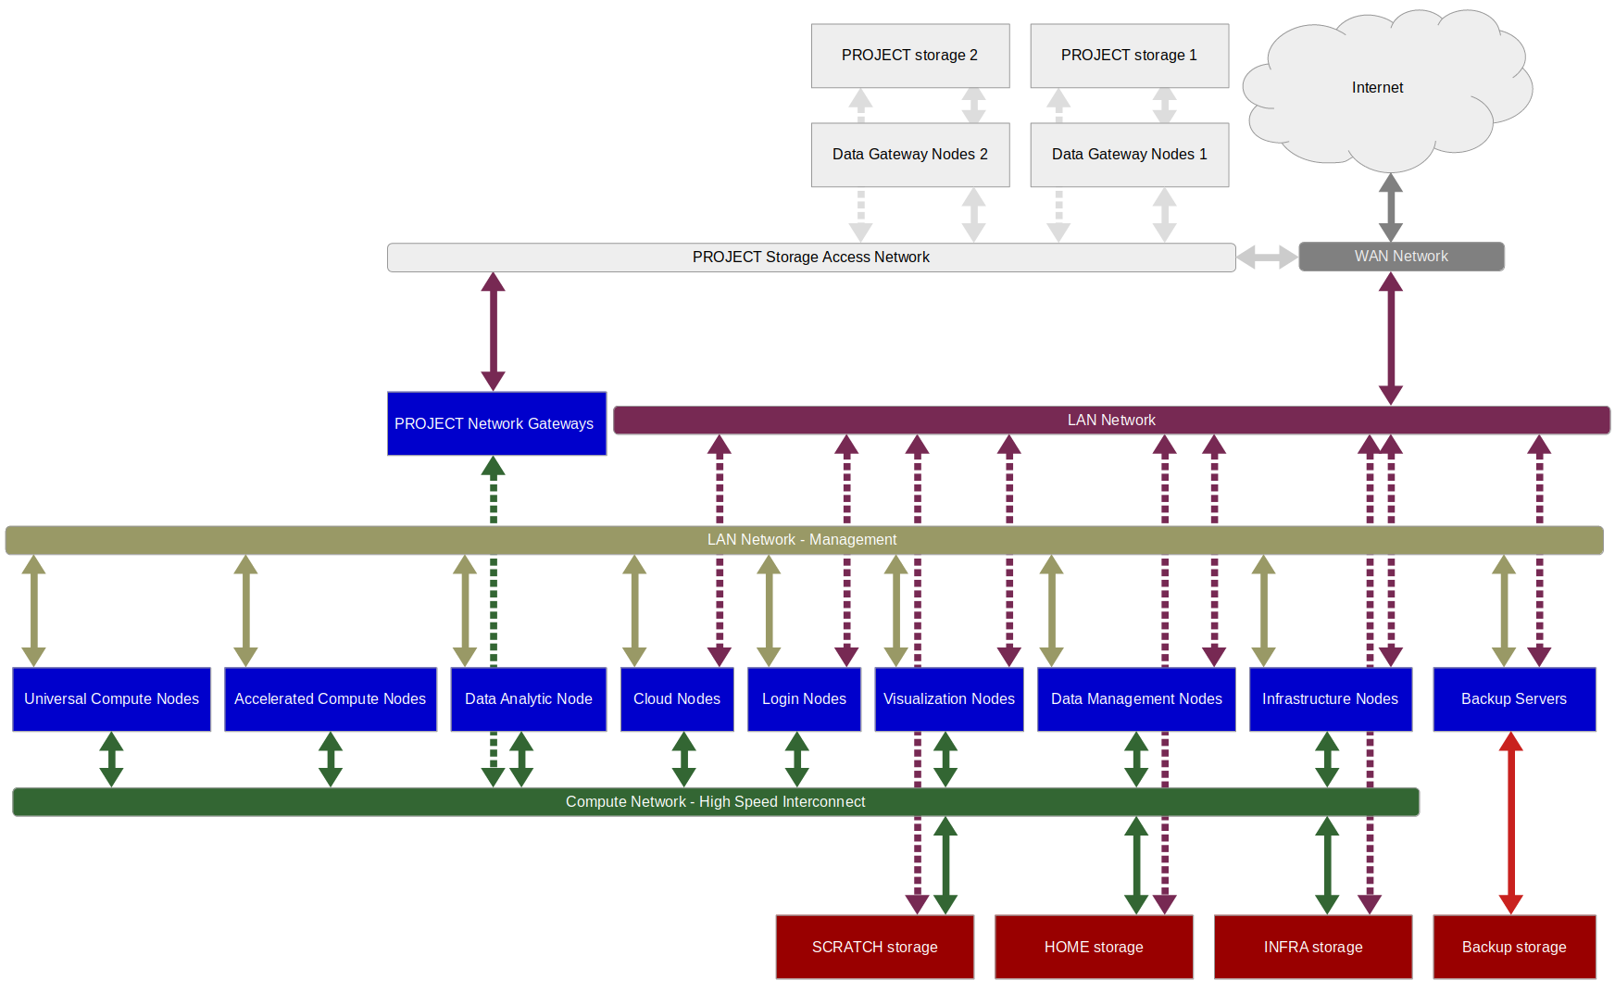
Figure 1 EURO_IT4I system diagram
The EURO_IT4I system diagram is a schematic/simplified illustration of EURO_IT4I system; it does not demonstrate either a complete system or all or exact interconnections. Grey-colored parts are not a part of the EURO_IT4I system delivery and are supplied by the contracting authority.

Requirements – Compute Cluster/Partitions
- The following benchmark must be used for Compute cluster performance measurement:
- High Performance LINPACK http://www.netlib.org/benchmark/hpl/
Referential benchmark implementation is not required for the measurement; optimized benchmark implementation can be used. Applied benchmark implementation must fully comply with benchmark specifications. If an optimized version of the benchmark is used, it has to be supplied to the contracting authority no later than at the time of acceptance tests.

- Rmax computing performance is determined by executing a High Performance LINPACK benchmark running parallel on all Compute nodes of the given partition (a single benchmark instance on the whole partition).

- Computing performance must be specified for the offered/delivered configuration designed for normal operation. The determined computing performance must not be conditioned in any way (e.g. by using a specific processor mode not suitable for long-term system operation; or by declaring expected efficiency not guaranteed by the supplier). Declared computing performance must be proven by corresponding acceptance tests during implementation.

- The sum of LINPACK Rmax computing performance of the individual compute partitions must be 8600 TFLOPS, at a minimum.

- (I) In the offer, the supplier must specify the theoretical computing performance Rpeak of individual Compute node for all compute partitions.

- (I) In the offer, the supplier must state Rmax computing performance according to SPEC_35 for each compute partition.

Requirements – Compute Nodes
- Each Compute node must meet the following requirements:
- x86-64 architecture
- 64-bit operating system, Linux, see section 4.20.4 Software – OS and Applications for details
- Compute network connection
- LAN connectivity

- Compute node RAM must be DDR4 with ECC.

- RAM must be evenly distributed (in terms of throughput, capacity, and access time) on processors and CPU cores of Compute node. RAM must consist of memory modules of the same type (size, rank, etc.), and must be distributed evenly, with the same configuration, on memory controllers and memory channels of Compute node. All memory channels of every processor in a node must be utilized.

- Compute nodes are intended exclusively for computing. The supplier must not use any Compute node to provide other functionality.

- All Compute nodes in the same partition must have identical hardware and software (e.g. firmware) configuration and must operate using the same configuration (frequency, timing, feature setting).

- (I) In the offer, the supplier must state the hardware platform of the solution and detailed configuration of Compute nodes including processor model.

- (I) In the offer, the supplier must provide the name and version of Compute node operating system.

Requirements – Universal Partition – Universal Nodes
- Universal partition must provide LINPACK Rmax computing performance of 1935 TFLOPS, at a minimum, using CPUs only.

- Each Universal node must meet the following requirements:
- Two CPU sockets/processors per node
- No accelerators
- For CPUs only, node theoretical computing performance Rpeak of 4000 GFLOPS, at a minimum, in double precision
- at least 2GiB of RAM per CPU core
- at least 256GiB of RAM per node
- RAM DDR4, at least 3000MT/s
- diskless; network boot from central image repository is required
- Compute network connection 100Gb/s, at a minimum
- LAN connectivity, see section 4.17 Requirements – LAN Infrastructure for details

Requirements – Accelerated Partition - Accelerated Nodes
- Accelerated partition must provide LINPACK Rmax computing performance of 4500 TFLOPS, at a minimum.

- Each Accelerated node must meet the following requirements:
- Two CPU sockets/processors per node
- PCI-Express gen 4, supported by all key components including CPUs, GPUs and Compute network adapters
- For CPUs only, node theoretical computing performance Rpeak of 2400 GFLOPS, at a minimum, in double precision
- 512GiB of RAM, DDR4, at least 3000MT/s
- LAN connectivity, see section 4.17 Requirements – LAN Infrastructure for details

- Each Accelerated node must contain at least eight GPU accelerators of the same type.

- Each GPU accelerator of accelerated nodes must meet the following requirements:
- CUDA technology support
- Theoretical computing performance Rpeak of 17 TFLOPS in double precision, at a minimum
- 40GiB HBM memory

- The GPU accelerators in accelerated node must be connected using high-speed connections/network. Connections between any two GPU accelerators in the node must provide theoretical throughput of at least 250GB/s in each direction simultaneously. The requirement must be met for simultaneous, parallel communication of all GPUs (GPU pairs) in the node. Each GPU accelerator must provide theoretical throughput of at least 250GB/s in each direction simultaneously.

- Each Accelerated node must contain PCIe gen 4 switches enabling the connection of GPU accelerators and Compute network adapters and CPUs.

- Each Accelerated node must provide Compute network connection 400Gb/s (2x200Gb/s or 4x100Gb/s). Compute network adapters need to be evenly distributed across the CPU sockets, connected directly to the PCIe switches where the GPU accelerators are connected.

- Accelerated node must provide unified memory spanned over node’s GPUs memory and node’s RAM memory. The unified memory must be accessible using CUDA API.

Requirements – Data Analytics Partition – Data Analytics Node
- The Data analytics partition must provide the LINPACK Rmax computing performance of 40 TFLOPS, at a minimum.

- EURO_IT4I system must contain one Data analytics node.

- The Data analytics node must meet the following requirements:
- NUMA SMP architecture, cache coherent memory access
- Thirty two CPU sockets/processors
- 24TiB RAM, DDR4, at least 2900MT/s, coherent memory
- Compute network connection 400Gb/s (4x100Gb/s or 2x200Gb/s)
- LAN connectivity, see section 4.17 Requirements – LAN Infrastructure for details

- The Data analytics node must be a single system allowing usage of all the resources by a single job, under a single instance of running OS. The Data analytics node must provide on-demand software partitioning using technologies like cgroups and cpusets to allow maximum utilization by multiple jobs/users with smaller requirements.

- The Data analytics node must provide fast memory access; the latency of remote NUMA node memory access must not be greater than six times the latency of local NUMA node memory access, idle latencies are considered. The memory latency will be evaluated using Intel Memory Latency Checker or similar tool.

- Software implementation of the memory coherency is not permitted.

Requirements – Cloud Partition – Cloud Nodes
- Cloud partition must provide the LINPACK Rmax computing performance of 131 TFLOPS.

- Each Cloud node must meet the following requirements:
- Two CPU sockets/processors per node
- 256GiB of RAM, DDR4, at least 3000MT/s
- 2 local NVMe disks with capacity of at least 480GB in RAID1, NVMe PCIe 4x lanes
- Compute network connection 100Gb/s, at a minimum
- LAN connectivity, see section 4.17 Requirements – LAN Infrastructure for details

- The Cloud node must have CPUs with the same architecture, core count, and frequency as the Universal nodes.

- Each Cloud node must have two dedicated (extra) Ethernet ports (at least 10Gb/s each) connected to two Ethernet networks/switches (for redundancy) providing VLANs to allow better utilization of the VMs running on the platform and the possibility to create user defined networks. These networks/switches are considered as a part of the LAN infrastructure, so requirements stated in section 4.17 Requirements – LAN Infrastructure apply.

Requirements – Compute Network
- Compute network must use a RDMA technology with the interconnection throughput of 100Gb/s, at a minimum, and interconnection latency of 10 microseconds, at a maximum. The equipment connection to Compute network and inside Compute network must meet the above-mentioned requirements for connections.

- Compute network must comply with one of the following characteristics:
- Compute network is a fully non-blocking network. Compute network consists of one switching device only – the director switch. The director switch has provably fully non-blocking internal interconnection and (theoretical) full bisection bandwidth.
- The Compute network topology is fully non-blocking Fat Tree. Compute network consists of two layers of switches, one layer of switches (leaf switches) is intended for connecting endpoints, the second layer of switches (spine switches) interconnects leaf switches; the layers are mutually bipartite connected. Tree topology of Compute network is balanced.
- The Compute network topology is Dragonfly+. Compute network is organized into groups/islands. Each island alone (intra-group connections) provides fully non-blocking communication of its endpoints. Each island consists of two layers of switches, one layer of switches (leaf switches) is intended for connecting endpoints, the second layer of switches (spine switches) is intended for connecting to other islands; the layers are mutually bipartite connected. Each island provides connectivity (aggregated throughput) to other islands equal or greater than 4/9 of connectivity of its endpoints. Connectivity to other islands is spread evenly. The maximum number of islands is four. Storages’ requested performance (see section 4.12 Requirements – Storages ), notably SCRATCH performance, can be reached from clients in any single island.
- The Compute network topology is Enhanced Hypercube. Each switch in the network provides the same connectivity (the number of links and their distribution and throughput) to the network. Switch connectivity is spread to all dimensions of the network. The number of links to each dimension is the same number or differs by one (i.e. for any two dimensions of the network the maximum difference of link count is one); links of the same speed are used; in the case of link count difference, lower dimensions have greater number of links than higher dimensions. The number of hypercube dimensions is less than or equal to six. For each switch, the ratio of connectivity-to-the-network to connectivity-to-endpoints is greater than or equal to 2.2. For the ratio calculation, if provided connectivity of endpoint is higher than connectivity requested in technical specification, the lower value can be used (e.g. if 100Gb/s connection to Compute network is requested and 200Gb/s speed is provided, then 100Gb/s can be used for ratio calculation).

- Compute network must use effective routing optimized for the topology and the configuration of Compute network.

- For the selected network topology/configuration (with regard to switch configuration and routing mechanism), connection of Accelerated nodes to Compute network must provide optimal communication.
For Fat Tree topology, corresponding ports of Accelerated nodes (e.g. port 1 of each Accelerated node) must be connected to minimal number of leaf switches.
For Dragonfly+ topology, all Accelerated compute nodes must be located in one island, corresponding ports of Accelerated nodes must be connected to minimal number of leaf switches.
For Enhanced Hypercube topology, corresponding ports of Accelerated nodes must be connected to minimal number of switches in the smallest sub-hypercube of Compute network.

- The solution must provide an effective MPI communication of Compute nodes.

- Compute network must support and provide an IP protocol.

- A system-wide LINPACK benchmark running parallel on all Compute nodes of the Compute cluster (utilizing only CPUs) must be possible.

- (I) In the offer, the supplier must state the technology, topology, throughput, latency of Compute network, and the equipment configuration.

- (I) In the offer, the supplier must state configuration and characteristics of proposed Compute network relevant for proposed network topology.

Requirements – Login Nodes
- EURO_IT4I system must include, at a minimum, four Login nodes.

- Each Login node must meet the following requirements:
- Physical node
- x86-64 architecture
- Two CPU sockets/processors per node
- For CPUs only, node theoretical computing performance Rpeak of 2400 GFLOPS, at a minimum, in double precision
- 256GiB RAM DDR4, at least 3000MT/s, ECC
- 2 local SSD disks with capacity of at least 480GB in RAID1
- Hot-swap disks
- Compute network connection 100Gb/s, at a minimum
- LAN connectivity, redundant, see section 4.17 Requirements – LAN Infrastructure for details
- Redundant, hot-swap power supply units, redundant power supplies

- The Login nodes must provide user access implementing an SSH2 protocol and services for SCP and SFTP file transfer.

- The Login nodes must use the identical technology and instruction set of processors as Universal nodes.

- The Login nodes must have the same hardware configuration and must operate in identical operating settings (frequency, latency, properties settings).

- The Login nodes are intended exclusively for providing user access and operations. The supplier must not use any Login node to provide other functionality.

- (I) In the offer, the supplier must state the hardware platform of the solution and detailed configuration of Login nodes including processor model.

- (I) In the offer, the supplier must provide the name and version of the Login node operating system.

Requirements – Visualization Nodes
- EURO_IT4I system must include two Visualization nodes, at a minimum.

- Each Visualization node must meet the following requirements:
- Physical node
- x86-64 architecture
- Two sockets/processors per node
- For CPUs only, node theoretical computing performance Rpeak of 2400 GFLOPS, at a minimum, in double precision
- 256GiB DDR4 RAM, at least 3000MT/s, ECC
- one powerful GPU card with OpenGL support
- 2 local SSD disks with capacity of at least 480GB in RAID1
- Hot-swap disks
- Compute network connection 100Gb/s, at a minimum
- LAN connectivity, redundant, see section 4.17 Requirements – LAN Infrastructure for details
- Redundant, hot-swap power supply units, redundant power supplies

- The Visualization nodes must provide remote hardware-accelerated visualization with OpenGL support.

- Visualization node GPU cards must meet the following requirements:
- Theoretical computing performance Rpeak of 12 TFLOPS, at a minimum, in single precision
- At a minimum 24GiB GPU memory
- GPU memory must be a continuous space with uniform addressing and uniform performance.

- Visualization nodes must be fully integrated into EURO_IT4I system in the same scope as Compute nodes. Specifically, this includes user account integration, authentication, integration and accessing Visualization node services via Scheduler, and storage accessibility.

- Visualization nodes must use the identical technology and instruction set of processors and as Universal nodes.

- Visualization nodes must have the same hardware configuration and must operate in identical operating settings (frequency, latency, properties settings).

- Visualization nodes are intended exclusively for user data visualization. The supplier must not use any Visualization node to provide other functionality.

- (I) In the offer, the supplier must state the hardware platform of the solution and detailed configuration of Visualization nodes including processor model.

- (I) In the offer, the supplier must provide the name and version of the Visualization node operating system.

- (I) In the offer, the supplier must state the name, version, and description of the Visualization node software.

Requirements – Storages

Requirements - SCRATCH Storage
- SCRATCH storage is a file storage intended exclusively for storing EURO_IT4I users’ data.

- SCRATCH storage must be independent of other storages.

- From the user’s point of view, SCRATCH file storage must behave as a single, continuous space with a single namespace.

- SCRATCH file storage must be accessible, mounted using a native protocol, on all Compute nodes, Login nodes, Visualization nodes, and Data Management nodes.

- On clients, SCRATCH file storage must be accessible on the /scratch path.

- SCRATCH file storage must have a net available capacity on file-system level of 1PB (1x10¹⁵byte).

- SCRATCH file storage must allow storing of 500 million files.

- SCRATCH storage must provide long-term sustainable sequential read performance for the 1MiB block size of 500GB/s (500x10⁹ byte/s). The required performance must be achievable from Compute nodes.

- SCRATCH storage must provide long-term sustainable sequential write performance for the 1MiB block size of 350GB/s (350x10⁹ byte/s). The required performance must be achievable from Compute nodes.

- SCRATCH storage must provide long-term sustainable random I/O performance for the block size of 4KiB and 80%/20% read/write mode of 5 million IOPs. The required performance must be achievable from Compute nodes.

- SCRATCH storage must be flash based. All data (including metadata) must be stored on SSD or NVMe disks. The disks must be suitable for their designation and expected load.

- (I) For SCRATCH storage, the supplier must state in the offer the net available capacity; long-term sustainable sequential performance for the 1MiB block size; and long-term sustainable random I/O performance with a block size of 4KiB and 80%/20% read/write mode.

- (I) For SCRATCH storage, the supplier must provide in the offer the storage architecture, configuration of the equipment, type and number of disks, RAID level, number of disks in RAID, number of spare disks, and software description.

Requirements – HOME Storage
- HOME storage is a file storage intended exclusively for storing EURO_IT4I users’ data.

- HOME storage must be independent of other storages with an exception of INFRA storage.
HOME and INFRA storage can share a storage backend (disk array or similar) but with clear association of individual disks to the specified storage (so one disk cannot be shared by HOME and INFRA storage).

- From the user’s point of view, HOME file storage must behave as a single, continuous space with a single namespace.

- HOME file storage must be accessible, mounted using a native protocol, on all Compute nodes, Login nodes, Visualization nodes, and Data Management nodes.

- On clients, HOME file storage must be accessible on the /home path.

- HOME file storage must have a net available capacity on file-system level of 25TB (25x10¹²byte).

- HOME file storage must allow storing of 500 million files.

- HOME storage must provide long-term sustainable sequential performance for the 1MiB block size of 1.2GB/s (1.2x10⁹ byte/s). The required performance must be achievable from Compute nodes.

- HOME storage must provide long-term sustainable random I/O performance for the block size of 4KiB and 80%/20% read/write mode of 7,000 IOPs. The required performance must be achievable from Compute nodes.

- HOME storage must be flash based. All data (including metadata) must be stored on SSD or NVMe disks. The disks must be suitable for their designation and expected load.

- HOME storage must not use Lustre file system technology, because it is not suitable for given purpose.

- (I) For HOME storage, the supplier must state in the offer the net available capacity; long-term sustainable sequential performance for the 1MiB block size; and long-term sustainable random I/O performance with a block size of 4KiB and 80%/20% read/write mode.

- (I) For HOME storage, the supplier must provide in the offer the storage architecture, configuration of the equipment, type and number of disks, RAID level, number of disks in RAID, number of spare disks and software description.

Requirements – INFRA Storage
- INFRA storage is a file storage intended for storing supercomputer infrastructure services data and contracting authority’s data necessary for providing HPC services to users.

- INFRA storage must be independent of other storages with an exception of HOME storage. See SPEC_109 for details.

- The contracting authority assumes the following use of INFRA storage:
- Node installation and boot images;
- Scheduler data and logs;
- Application software provided by contracting authority.
Based on the assumed use the required storage parameters were determined.

- The supplier can use INFRA storage for purposes other than stated in SPEC_123; however, the supplier must adequately increase the storage parameters and ensure compliance with the parameters requested by the contracting authority.

- INFRA file storage must have a net available capacity on file-system level of 25TB (25x10¹²byte).

- INFRA file storage must allow storing of 500 million files.

- INFRA storage must provide long-term sustainable sequential performance for the 1MiB block size of 1.2GB/s (1.2x10⁹ byte/s). The required performance must be achievable from Compute nodes and from Infrastructure nodes independently.

- INFRA storage must provide long-term sustainable random I/O performance for the block size of 4KiB and 80%/20% read/write mode of 7,000 IOPs. The required performance must be achievable from Compute nodes and from Infrastructure nodes.

- INFRA storage must be flash-based. All data (including metadata) must be stored on SSD or NVMe disks. The disks must be suitable for their designation and expected load.

- INFRA file storage must allow partitioning of data capacity into logical partitions/file systems of the required size and making these partitions/file systems available only to selected nodes.

- INFRA storage solution must be available to all EURO_IT4I system’s nodes.

- INFRA storage must make available:
  - Node installation images – on Infrastructure nodes providing remote installation service or remote network boot service;
  - Scheduler data and logs – on Infrastructure nodes running Scheduler;
  - Elasticsearch data (in the case INFRA storage is used for this purpose) – on Infrastructure nodes running Elasticsearch;
  - Contracting authority’s application software – on Compute, Login, and Visualization nodes, on Data management nodes, and on selected Infrastructure nodes.
For each of the above-mentioned nodes, a data path to INFRA storage must exist with throughput of 10Gb/s, at a minimum.

- INFRA storage must not use Lustre file system technology, because it is not suitable for given purpose.

- (I) For INFRA storage, the supplier must state in the offer the net available capacity; long-term sustainable sequential performance for the 1MiB block size; and long-term sustainable random I/O performance with a block size of 4KiB and 80%/20% read/write mode.

- (I) For INFRA storage, the supplier must provide in the offer the storage architecture, configuration of the equipment, type and number of disks, RAID level, number of disks in RAID, number of spare disks, and software description.

Requirements specified in the following sections are common for all file storages – HOME, SCRATCH and INFRA storages.

Requirements – File Storage
- The file storage must provide shared network file system services.

- File storage clients must provide standard file system functionalities (in the POSIX way).

- On the client side, the file storage must be transparently integrated into the operating system, must allow for standard file operations and implement the usual semantics of native file systems, must support a native OS file system interface (API) and integrate operating system users as file system users.

- The file storage must meet the following requirements:
- Unicode support in file names;
- Long file names support;
- Access control, standard Unix permissions (read, write, execute; user, group, others) and extended ACL;
- User quotas, limits for disk capacity and number of files configurable individually for each user;
- Group quotas, limits for disk capacity and number of files configurable individually for each group;
- Reporting of used capacity and number of files for individual users and groups;
- Support for files larger than 1TB;
- Symbolic links support;
- File locking support.
User and group quotas are not expected to be enabled on INFRA storage file systems.

- Single, continuous space with a single namespace means that the user uses a single namespace to access the files in the storage, and all the capacity and properties of the file storage are available within that single namespace.

- Storage services must not negatively affect each other. The requested sequential and random I/O performance must be achievable under simultaneous parallel load on all storages.

Requirements – Availability, Redundancy
- The storage solution must provide high availability. The storage must not contain any component whose outage could cause a failure of the storage services (no “single point of failure” must exist).

Storage solution components, specifically disks, power supply units, disk array controllers, switches, and servers must be redundant and hot-swappable without storage services outage.

A redundant disk array is not considered a “single point of failure” if the disk array only consists of dual-port disks and there are multiple independent data paths for all disks.

- Failure or outage of any single storage server or network device must not cause a failure of storage services.

During a failure or outage of a storage server or network device, the storage performance can be lower than required.

- The storage solution must be designed for long-term heavy load.

- (I) In the offer, the supplier must provide the details about the solution for high availability and redundancy of the supplied systems and equipment.

Requirements – Disk Redundancy
- The storage must provide sufficient redundancy so that a failure of any two disks will not cause data loss.

- The storage must provide recovery from disk failure, i.e. re-ensuring the required data redundancy (e.g. RAID group reconstruction using hot-spare disks). Recovery from disk failure must occur automatically, without operator‘s intervention.

- Recovery from disk failure, i.e. re-ensuring the required data redundancy, must be completed within 48 hours of disk failure. During recovery, the storage performance can be temporarily lower than required.

- The storage configuration must ensure required data redundancy after a failure of any two disks of the storage, without operator’s intervention.

- Each disk array or similar equipment of the storage solution must provide a reserve capacity or spare disks in the number or capacity of
$max\left(\frac{1}{24}∗{number}_{};2\right)$ disks, at a minimum, for each type of disk in the disk array.
The max(a; b) function returns the larger value from a, b. The result is rounded up to the nearest integer.
The number_of_disks value is the number of disks of the same type in the disk array. The value includes all disks - the disks with data and parity data, as well as spare disks and reserve capacity.

- (I) In the delivery, the supplier must provide the details about the storage redundancy, number and type of disks, RAID level, number of disks in RAID, number of spare disks, and storage software solution description.

Definition – Storage Capacity
- The data storage capacity (size) is required and must be stated as the net usable capacity, i.e. the storage capacity actually usable by the user at the highest service level provided.
The file storage capacity is the capacity of the file system provided by the storage.

- The storage net usable capacity must be stated for offered/delivered configuration designed for normal operation.

- All required/offered capacities (including the metadata capacity required for storing the requested number of files) must be achievable simultaneously.

- Determination of the net usable capacity must not take into account the features of the system or its component, which could provide larger storing capacity under conditions that cannot be ensured (compression, deduplication, etc.).

- Determination of the net usable capacity must not take into account the features of the system or its component, which could allow allocating more space than physically possible or practically feasible without further action (oversubscription).

- Storage capacity is specified using prefixes of decimal multiples.
Gigabyte (GB) 10⁹ byte
Terabyte (TB) 10¹² byte
Petabyte (PB) 10¹⁵ byte

- The net available storage capacity is determined on a suitable storage client system by writing to the storage until it is full, or reading the entire storage, or by a suitable system tool demonstrating the size/storage capacity.

- The tools used to determine the capacity must provide reliable information and work with a known data block size or a known and accurate unit.
In Linux OS, the file system capacity in bytes can be displayed using the df -B1 command, value “Available“.

Definition – Storage Performance
- The storage performance (sequential performance, I/O performance, metadata performance) is required and must be stated as the long-term performance realistically sustainable by the user from storage clients at the highest service level provided.

- The file storage performance is the long-term, realistically sustainable performance of operations performed on file storage systems from file storage clients.

- The storage performance must be stated for the offered/delivered configuration designed for normal operation.

- The storage performance must be determined for highly occupied storage (see the benchmark specifications for details).

- The storage performance must be determined for non-privileged user operations.

- The performance must not be determined based on the assumption of specific, favorable conditions or specific, advantageous measurement modes (e.g. cache operation), unless such conditions or modes are explicitly required.

- The storage performance is specified using prefixes of decimal multiples.

Performance Measurement
- The supplier must demonstrate compliance with the storage performance requirements by running performance tests (benchmarks) within the acceptance tests (performance measurements).

- The performance tests must be run on test servers configured as file storage clients.

- The test server disk caches must be cleared before each storage performance measurement.

- The performance measurement must be carried out by procedures and under conditions that correspond to normal operation – normal provision of storage services. No action must be taken prior to and during measurement of the storage performance that would affect the measurement result.

- (I) In the delivery, the supplier must state the proposal of the performance measurement implementation.

Using FIO Benchmark for Performance Measurement

- The file storage sequential performance and random I/O performance must be measured with fio version 3.13 in client-server mode. Other/newer version of the application can be used only with the approval of the contracting authority.
Fio is an open source tool (GPL license version 2) for I/O benchmarking and testing, available at https://github.com/axboe/fio.

Accessibility of the measured file storage is verified on each server dedicated to file storage measurement (test servers according to SPEC_168) and the fio tool in server mode is run:
fio --server

The measurement is initiated from the selected server – the fio tool is run in client mode:
time fio \
--client=machinefile jobfile \
--output-format=normal,json |& \
tee fio.out

In the machinefile file, the names of all test servers for storage measurement are specified, one name per line.
Jobfile – the fio tool configuration file – contains the test description according to the specified measurement. The jobfile file is stored on the server initiating the measurement.

Fio program must be executed by an unprivileged user.

The file storage directory used to store test measurement files (the directory setting in the jobfile) must be empty before the measurement.
The test files must be prepared in the directory before the sequential read performance measurement and before random I/O performance measurement. To create the test files, run the fio tool in the client mode and set the create_only=1 parameter in the respective jobfile. By modifying the bs parameter, you can change the block size, as well.

Test directories and files must be owned by an unprivileged user.

The fio output on the server that initiated the measurement (i.e. the fio.out file) will be used to determine the result. The measurement summary information provided under “All clients” will be used – in JSON output format.
In JSON output, the last item of the client_stats attribute is used, the value of the jobname attribute of this item is All clients, this item is hereinafter referred to as the summary.
The value of the bw_bytes attribute of the read or write (depending on the operation type) attribute of the summary represents the respective sequential performance (throughput) in bytes per second.
To measure the random I/O performance, the sum of the values of the iops attribute of the read and write attributes of the summary represents the total number of I/O operations per second (IOPS).
For SCRATCH storage performance measurement, multiple simultaneously running instances of fio benchmark can be used, in this case the same timing and the same runtime of instances and accurate calculation must be guaranteed.

Sequential Performance Measurement
- The long-term sustainable sequential performance must be measured with the fio tool according to SPEC_172.

The storage sequential performance is the lower of the two values – file storage sequential read performance and file storage sequential write performance.

For file storage sequential write performance, use the following configuration file – fio jobfile:

[global]
rw=write
bs=1M
create_on_open=1
time_based
runtime=1h
numjobs=NUMJOBS

[name_of_file_storage]
directory=/path_to_filesystem/test/fio
filesize=FILESIZE

For file storage sequential read performance, use the following configuration file – fio jobfile:

[global]
rw=read
bs=1M
time_based
runtime=1h
numjobs=NUMJOBS
;create_only=1

[name_of_file_storage]
directory=/path_to_filesystem/test/fio
filesize=FILESIZE

Replace the NUMJOBS and FILESIZE parameters with suitable values.
The NUMJOBS parameter indicates the number of parallel tasks performed on the test server; the value is an integer.
The FILESIZE parameter indicates the size of individual files that the job is working with; the value is the size according to the fio tool syntax (e.g. 30T).
Total size of the files with which the measurement works from one test server, i.e. the FILESIZE * NUMJOBS value, must be greater than 20 times the memory size of each test server.
Total size of the files with which the measurement works from all used test servers, i.e. the FILESIZE * NUMJOBS * number_of_test_servers value must be greater than
- for SCRATCH storage: 900TB;
- for INFRA storage: 20TB;
- for HOME storage: 20TB.

Random I/O Performance Measurement
- The long-term sustainable random I/O performance must be measured with the fio tool according to SPEC_172.

Use the following configuration file – fio jobfile.

[global]
rw=randrw
rwmixread=80
bs=4k
time_based
runtime=1h
numjobs=NUMJOBS
;create_only=1

[name_of_file_storage]
directory=/path_to_filesystem/test/fio
filesize=FILESIZE

Replace the NUMJOBS and FILESIZE parameters with suitable values.
The NUMJOBS parameter indicates the number of parallel tasks performed on the test server; the value is an integer.
The FILESIZE parameter indicates the size of individual files that the job is working with; the value is the size according to the fio tool syntax (e.g. 30T).
Total size of the files with which the measurement works from one test server, i.e. the FILESIZE * NUMJOBS value, must be greater than 20 times the memory size of each test server.
Total size of the files with which the measurement works from all used test servers, i.e. the FILESIZE * NUMJOBS * number_of_test_servers value must be greater than
- for SCRATCH storage: 900TB;
- for INFRA storage: 20TB;
- for HOME storage: 20TB.

Metadata Performance Measurement
- In order to verify the stability of the file storage metadata operations and to determine the file storage metadata performance, the long-term sustainable performance of the file storage metadata operations must be measured as acceptance tests.

- The long-term sustainable metadata performance must be measured using the mdtest tool version 3.2.1 https://github.com/hpc/ior. Other/newer version of the application can be used only with the approval of the contracting authority.

For measurement, use the following command:
time \
mpirun -n $NPROC -machinefile \
mdtest \
-C -T -r \
-F \
-d /path_to_filesystem/test/mdtest \
-I $FILES_PER_DIR \
-i $ITERATIONS \
-u \
-z $TREE_DEPTH -b $BRANCHING_FACTOR \
-L
where machinefile is the file containing the names of the test servers (as specified in SPEC_167), one name per line,
the NPROC, FILES_PER_DIR ITERATIONS, TREE_DEPTH, BRANCHING_FACTOR variables are positive integers determined so that:
- The FILES_PER_DIR value is greater than or equal to 100;
- The number of files created in each iteration is 10⁸, at a minimum, i.e.
${NPROC∗{FILES}_{}∗{BRANCHING}_{FACTOR}}^{{TREE}_{DEPTH}}≥{10}^{8}$ ;
- The test run time is 1 hour, at a minimum.
The result is the values at the “File creation” and “File stat” lines, in the “Mean” column, of the “SUMMARY rate” table.

Requirements – Data Management Nodes
- EURO_IT4I system must include, at a minimum, two servers operating exclusively as Data management nodes – nodes designed for data transfer between supercomputer’s storages and external storages.

- Each Data management node must meet the following requirements:
- Physical node
- x86-64 architecture
- At least one processor, at least 16 CPU cores total;
- At least 128GiB RAM, operated in DDR4 mode, at least 2666MT/s with ECC;
- The RAM must consist of memory modules of the same parameters, evenly distributed across all server memory;
- Theoretical throughput of processor(s) to RAM at least 160GB/s (in the offered server configuration);
- At least 2 local SSD disks with the capacity of 240GB, at a minimum, in RAID1;
- Hot-swap disks;
- Redundant, hot-swap power supply units, redundant power supplies.
- Compute network connection 100Gb/s, at a minimum
- LAN connection, redundant, see section 4.17 Requirements – LAN Infrastructure for details

- On Data management nodes, HOME and SCRATCH file storages must be accessible, mounted via native protocol.

- The Data management nodes must provide protocols for SFTP and SCP file transfer and ensure transfer from/to HOME and SCRATCH. On Data management nodes, the contracting authority will install and operate GridFTP and other services.

- Data management nodes must be integrated into EURO_IT4I system. Specifically, this includes user account integration, authentication, and integrating and accessing Data management nodes services via Scheduler. Data management nodes must be clients of the Scheduler.

- (I) In the offer, the supplier must provide the description and detailed configuration of Data management nodes including processor model.

- (I) In the offer, the supplier must provide the name and version of the Data management node operating system.

Requirements – PROJECT Network Gateways
PROJECT data storage is the contracting authority storage designed for storing multi-year user project data and sharing of the data between IT4Innovations supercomputers.
PROJECT data storage is not yet implemented and the contracting authority does not know the exact equipment specifications.

PROJECT Network Gateways are servers intended for connecting EURO_IT4I system Compute Network with PROJECT data storage Access Network (100Gb/s Ethernet network).

- The delivery must include, at a minimum, four PROJECT Network Gateways.

- Each PROJECT Network Gateway server must meet the following requirements:
- Physical server;
- x86-64 architecture;
- Linux 64-bit, CENTOS 7 (or newer) or RHEL 7 (or newer) operating system;
- At least one processor, at least 3GHz base frequency, at least 16 CPU cores total;
- At least 32GiB RAM, operated in DDR4 mode, at least 2900MT/s with ECC;
- The RAM must consist of memory modules of the same parameters, evenly distributed across all server memory;
- Theoretical throughput of processor(s) to RAM at least 160GB/s (in the offered server configuration);
- At least 2 local SSD disks with the capacity of 120GB, at a minimum, in RAID1;
- Hot-swap disks;
- Redundant, hot-swap power supply units, redundant power supplies.

- Each PROJECT Network Gateway node must provide a connection to EURO_IT4I system Compute Network with aggregated throughput of at least 100Gb/s.
- Each PROJECT Network Gateway node must provide a connection to PROJECT Access Network with aggregated throughput of at least 100Gb/s. For this purpose, the contracting authority reserves four 100Gb/s Ethernet QSFP28 type ports in edge devices of PROJECT data storage Access Network (two ports in each edge device). A part of the delivery are modules and optical cables required for connection to the edge devices of PROJECT data storage Access Network. Network cabling in the Data center dropped ceiling is required.
Location of PROJECT data storage and cable routes are described in section 8.6 WAN/LAN Network.

- The supplier must cooperate with the contracting authority in:
- Provisioning of Compute network adapter software stack on PROJECT Network Gateways;
- Provisioning of interconnecting, addressing, and routing Compute Network and PROJECT Access Network;
- Provisioning of NFS mounpoints of PROJECT file storages on the Compute nodes, Login nodes, Visualization nodes, and Data management nodes.

- (I) In the offer, the supplier must state count and detailed configuration of PROJECT Network Gateways.

Requirements – Infrastructure Nodes
- Infrastructure nodes and their infrastructure must be designed so that they ensure reliable, secure, fast, and effective operation and administration of EURO_IT4I system.

- Virtualization technology can be used for implementation of infrastructure for Infrastructure nodes; therefore, Infrastructure nodes can be realized by virtual servers. Nevertheless, the virtualization must not negatively affect the solution.

- EURO_IT4I system must include at least six physical Infrastructure nodes or at least three physical host servers of virtualization infrastructure for Infrastructure nodes. These servers must provide at least 384GiB of RAM memory in total.

- Each physical server referred in SPEC_192 must meet the following requirements:
- Disks in RAID with data redundancy
- Hot swap disks
- Redundant, hot swap power supply units, redundant power supplies
- LAN connection, see section 4.17 Requirements – LAN Infrastructure for details

- Failure or outage of any single infrastructure node must not interrupt currently running computing jobs and operation of Compute clusters, Login nodes, Visualization nodes, storages, Data management nodes, backup, network, or supercomputer administration.

- The key services must be run in high-availability mode, preferably using the native mechanisms of the services.

- (I) In the offer, the supplier must state the number of infrastructure nodes, their purpose, and detailed configuration.

Requirements – Backup Solution
- A part of the delivery must be a comprehensive solution for data backup.
Redundancy is not considered a backup. EURO_IT4I system must contain functionality and infrastructure, which enable creation of logically and hardware independent copies of production data on backup storage.

- The Backup solution must particularly provide the following:
- Backup of all delivered servers/nodes, with an exception of Compute nodes provisioned from images
- Backup of image repository (images) for nodes provisioning (it may be a part of backup of INFRA storage)
- Backup of HOME storage; SCRATCH storage is not subject to backup.
- Backup of INFRA storage

For HOME storage, 80% space usage of total capacity and large amount of small files is assumed. It is assumed that 4% of HOME storage total capacity will change daily.
For INFRA storage, 80% space usage of total capacity and large amount of small files is assumed. It is assumed that 4% of INFRA storage total capacity will change daily.
It is not necessary to back up temporary server data, which is not required for server operation recovery.

- Data must be backed up every 24 hours between 10:00 p.m. and 6:00 a.m. (i.e. during an eight-hour period, at a maximum).

- The backup solution must provide data recovery from the last 21 daily backups.

- The backup solution must provide sufficient backup capacity to meet all the requirements (with regard to the technology used and realistically achievable parameters in the given application).

- Data backup and recovery priorities (from the highest to lowest priority):
- Highest priority: Nodes critical for providing system services, INFRA storage
- Other nodes
- Lowest priority: HOME storage

- The data backup and restore solution must meet the following basic properties:
- Time schedule of backups
- Individual files and directories backup and restore
- Files and directories’ owners, permissions, extended ACLs, and attributes backup and restore
- Parallel run of backups and recoveries

- The backup solution must use a backup-to-disk technology. It is assumed that a technology for effective data storage will be used (e.g. compression or de-duplication).

- Backup must use a dedicated, independent data storage. Backup data storage must meet the requirements in sections 4.12.5 Requirements – Availability, Redundancy and 4.12.6 Requirements – Disk Redundancy.

- The backup solution must have a minimal negative impact on EURO_IT4I system operation and performance.

- The backup system license must cover all the requirements in maximum scope.

- (I) In the offer, the supplier must state the backup solution capacity and throughput which must be sufficient to meet the backup requirements.

- (I) In the offer, the supplier must describe in detail the calculation of required capacity to meet the contracting authority’s backup requirements.

- (I) In the offer, the supplier must state solution architecture, configuration of equipment, description of backup software solution, its properties, and suggested backup policy.

Requirements – LAN Infrastructure

LAN - General
- The LAN must provide communication between the equipment in the supercomputer and connection to the contracting authority’s WAN.

- The LAN must include the public and private parts of the network.

- The public parts of the network (hereinafter referred to as public networks) must use IPv4 and IPv6 public addresses and must provide services accessible from the Internet (Login nodes, Visualization nodes, Data management nodes).

- The private parts of the network (hereinafter referred to as private networks) must use IPv4 private addresses and be used for internal services and device management.

- Devices in private networks must have access to the Internet over NAT.
NAT will be provided by a contracting authority’s network device located in the contracting authority’s WAN.

- The network solution must support IPv6.

- The LAN must be divided into several L3 networks. For each L3 network, a different L2 network must be used (VLAN or another network device). It is not desirable to use one L2 network for multiple L3 networks. LAN division must separate the following types of communication into different L3 networks:
- Services accessible from the Internet
- Data communication between nodes (services)
- Infrastructure nodes and services
- Network devices management
- Disk arrays, storage management
- Server (BMC, IPMI, etc.) management
- Non-IT infrastructure (power supply, cooling, etc.) management

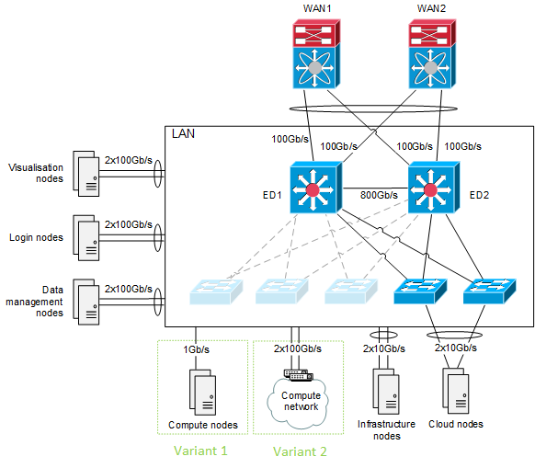
Figure 2 Network schema

LAN – Edge devices
- Connection of the LAN with the contracting authority’s WAN must be implemented by redundant L3 switches (hereinafter referred to as Edge devices, labeled as ED1, ED2 in the figure 2). Edge devices must meet the following requirements:
- Dual power supply
- Redundant server connection using multi-chassis ether channel
- Edge devices interconnection throughput of 800Gb/s, at a minimum
- Separate routing instances for private and public networks
- Support Access Control Lists (ACL) for at least 2000 ingress and 2000 egress ACL rules configurable for each port independently.

- In the case of separate control-plane of Edge devices, the edge devices must allow usage of HSRP, VRRP or similar router redundancy technology, where keepalive communication is done over IP addresses of subnet (private) different from floating IP address from public IP range, therefore not wasting public IP address for keepalive communication.

- Edge devices must support user authentication using RADIUS or TACACS+ protocol, creating of different user roles for network management (operator, administrator, etc.), and issued commands logging.

- Edge devices must support import and export of its device configuration using TFTP, FTP, SCP, or SFTP protocol. Configuration must allow saving in the form, which allows its editing using text editor.

- Edge devices must support IPFIX (Internet Protocol Flow Information eXport), or NetFlow v9, or sFlow v5. Data flow export must provide information about all IP packets (NetFlow standard, full NetFlow), or at least about one packet from 10 processed IP packets (sFlow, sampled NetFlow standards, sampling rate 1:10).

LAN – connections
- Minimum LAN connection speed of devices:
Minimum connection speed of each Login node, Visualization node and Data management node is 100Gb/s.
Minimum LAN connection speed of each Infrastructure node is 10Gb/s.
In the case of direct connection of Compute nodes to LAN, minimum speed of each node must be 1Gb/s.

- Minimum speed specified in SPEC_223 must be reachable when accessed from the contracting authority’s WAN. For systems specified in SPEC_225, the minimum speed requirement must be met even in the case when any single active network device fails.

- Connection of Login nodes, Visualization nodes, Data management nodes, and Infrastructure nodes to LAN must be redundant.

- Aggregated connection speed of Login nodes, Visualization nodes, and Data managements nodes in LAN reachable from the contracting authority’s WAN must be 400Gb/s.

- Aggregated connection speed of Compute nodes in LAN reachable from the contracting authority’s WAN must be at least 10Gb/s.

- In case there is no direct connection of Compute nodes to LAN, the solution must include a redundant LAN gateway solution to ensure IP connectivity for the devices in Compute network. LAN gateway solution must provide connection 2x100Gb/s to Compute network.

LAN – Active network devices
These requirements are common for all active network devices including Edge devices.

- Active network devices must support VLAN segmentation using 802.1Q standard with at least 100 VLANs and numbering from 1 to 4094.

- Active network devices must support IGMPv2 a IGMPv3 protocols.

- Active network devices, which are L3 devices, must support IPv4 multicast routing and PIM Sparse Mode and PIM Source-Specific Multicast protocols.

- Active network devices must be remotely controllable and centrally manageable.

- Active network devices must support SNMPv2 and SNMPv3 protocols enabling:
  - Reading of device state and ports utilization
  - Sending of SNMP traps for defined events

- Active network devices must support remote access using SSH2 protocol with at least AES256-CTR encryption protocol, HMAC-SHA256 hashing protocol and RSA key of 4096 bits.

- Management interfaces of active network devices must be connected to the contracting authority’s OOB network.
Serial management interfaces of edge devices must be connected to the contracting authority’s OOB router (Cisco 2901/K9). The supplier must provide required cables and installation.
Ethernet management interfaces of all active network devices and of nodes described in SPEC_279 must be connected to the contracting authority’s OOB network implemented by the contracting authority’s OOB switch. The supplier may utilize, at a maximum, one GBase-T Ethernet port of the contracting authority’s OOB switch. The supplier must provide required cables and cabling installation. Cable routes are described in section 8.6 WAN/LAN Network.

- (I) In the offer, the supplier must provide description of the Edge devices.

Requirements – WAN Integration
- Connection to the contracting authority’s WAN/LAN must provide connectivity of 4x100Gb/s.

- Each LAN edge device of EURO_IT4I system must be connected to each of the two central devices of the contracting authority’s WAN/LAN using a 100Gb/s connection. For this purpose, the contracting authority reserves four ports in WAN/LAN central devices WAN1 and WAN2. The ports are equipped with QSFP-100G-SR4 modules with MPO-12 connectors. The delivery must include the modules and fiber-optic cables required for connection of edge devices to the WAN1 and WAN2 devices. It is required to install network cabling in the data center suspended ceiling.
The WAN/LAN infrastructure of the contracting authority and cable routes are described in Chapter 8.6 WAN/LAN Network.
- Twelve Cat6a connections must be provided between the location of LAN edge devices and the contracting authority’s WAN/LAN described in Chapter 8.6 WAN/LAN Network. The supplier must provide Cat6a patch panel with RJ-45 ports at the location of LAN edge devices and connect it with existing patch panel in the contracting authority’s WAN/LAN rack. Connections may be used for OOB connections mentioned in SPEC_235.
- Connection of edge devices and the contracting authority’s WAN devices must be realized over Ethernet and private IPv4 in separate routing instances.

- Connection to the contracting authority‘s WAN devices must be redundant.

- (I) In the offer, the supplier must provide description of the WAN integration.

General Technical Requirements
- All servers (with the exception of Compute nodes) and disk arrays (including disk modules of disk arrays) must use:
- Redundant, hot-swap power supply units
- Redundant power supplies
- Hot-swap disks

- All devices and systems must provide remote management.

- All servers (nodes) must allow replacement of CPUs, RAM memory modules, and Compute network adapters (if present) independently of other components.

- All servers must have remote network management, independent of OS operation, providing power supply control, reset option, graphical console and virtual media.

- Disk array controllers must be redundant. Failure or outage of any single disk array controller must not cause a failure of disk array services. Disk array controller cache must be protected against data loss or corruption in case of power outage or any single controller failure.

- All disk array controllers and server RAM modules must use an error detection and correction mechanism – Error-correcting code memory (ECC memory).

- The parameters and characteristics of the disks used in the solution must be appropriate to their deployment and load. The warranty also applies to disk wear (including SSDs and NVMe drives) due to excessive use.

- Normal operation and accessibility of declared capacities must not require operator’s intervention.

- In the case of SSH, SCP, and/or SFTP protocol support, protocol version 2 must be supported.

- All devices and cables must be physically labeled with unique identification (labels). The identification must be easily accessible, legible and properly recorded.

Requirements – Software
- A part of EURO_IT4I system must be a comprehensive HPC system software solution, i.e. all software equipment required to fulfill the contracting authority’s requirements (firmware, operating systems, drivers, management, and monitoring software, file systems, scheduler, etc.).

All delivered software must be licensed for unlimited time, with no additional fees (at the version level applicable at the time of delivery).

Software - Environment
- EURO_IT4I system must deliver a transparent, uniform, shared user environment to end users.

- EURO_IT4I system must provide, to the maximum extent possible, uniform environment on all nodes accessible to end users, i.e. Login nodes, Compute nodes and Visualization nodes.
User environment on nodes of the same type must be identical.
User environment on nodes of different types must be identical to the maximum extent possible; environment differences arise only from differences in the nature and services of servers.
Environment means especially behavior of systems, applications, names of files, directories, commands, environment variables, values of environment variables, configuration, etc.
Nodes must provide en_US and C locale.

- Login nodes must provide end users with a command-line and graphical interface. Login nodes must provide shell (bash and csh) and X Window System (X11).

- EURO_IT4I system must provide end users with unified account and unified authentication. End user accounts must be accessible and identical on all Login, Compute, and Visualization nodes and Data management nodes.

- User account implementation must use LDAP and SSSD technology. User accounts must be stored and managed in the LDAP database. User accounts and groups must be created via posixAccount and posixGroup LDAP schemas. User accounts and groups must be managed via a secure LDAP protocol. The contracting authority will manage user accounts and groups exclusively. The contracting authority provides centralized management of all IT4Innovations center users; the contracting authority will synchronize EURO_IT4I system users and groups information from their central repository to EURO_IT4I system LDAP database. User home directories will also be managed exclusively by the contracting authority.
EURO_IT4I system LDAP service must be implemented using two LDAP servers with a replicated database. LDAP service must be implemented on suitable infrastructure nodes. Reservation of these nodes for running the LDAP service is not required. For the LDAP service, the OpenLDAP software is preferred.
SSSD service must be used for name/uid, group/gid resolving on nodes providing user access. Secure LDAP protocol must be used for accessing LDAP service. Login nodes, Visualization nodes, and Data management nodes must use SSSD enumeration.

- The unified user authentication must use SSH keys. The SSH keys will be managed by the contracting authority or user and must be stored in the LDAP database or user’s home directory. The SSH service must allow authentication of authorized user’s SSH keys against user’s entry in the LDAP database. It is assumed that the solution will be implemented using a configuration of SSHD and SSSD features. The contracting authority expects that there will be no end user authentication requiring password authentication.

Software - Scheduler
- EURO_IT4I system must provide unified access to computing resources. For access to computing resources and for performing computational jobs on Compute nodes, Visualization nodes, and Data management nodes, EURO_IT4I system must use an advanced job scheduler and resource manager (hereinafter referred to as Scheduler).

- Scheduler must effectively utilize available computing resources, taking into account specific features of Compute nodes and Compute network. Scheduler must allow advanced scheduling policies. Scheduler must allow executing of batch and interactive jobs. Scheduler must support job priorities and job dependencies. Scheduler must take into account current resources availability. Scheduler must handle compute resource failures and outages. Scheduler must allow scheduling according to resources resolved statically or dynamically.

- Scheduler must allow checking status of computational jobs. Scheduler must allow event notification (on job abort/begin/end execution) by email. Scheduler must allow users to submit jobs and monitor their status. Scheduler must return user jobs output back to submit location. Scheduler must allow operators to display jobs status, scheduler’s server and queues status and details of individual jobs.

- Scheduler must use high availability cluster, at least in the active-passive mode.

- Scheduler must provide information about users’ computational jobs resource consumption for accounting purposes. Required information is especially job runtime, names of allocated Compute nodes and number of allocated compute cores.

- Scheduler must allow execution of custom scripts defined by the contracting authority before and after job execution (prologue, epilogue), when submitting jobs to Scheduler and while modifying jobs (hooks).

- Scheduler must allow creating allocation of a set of nodes of specified properties available in a specified period to a specified group of users (reservation).

- Scheduler must allow limiting the number of concurrent user jobs, the number of concurrent user group jobs, the maximum duration of a job, and access to computational resources only to authorized users (ACL).

- Scheduler must take into account the Compute network topology to allow better parallel job placement on Compute nodes with higher communication efficiency.

- Scheduler must provide command-line interface and API in the C language.

- Scheduler must be PBS compatible (reasons being: integration into the contracting authority’s current systems, their knowledge and operation of their own integration, visualization, and management tools, and minimization of the number of operated software platforms).

- The server part of the Scheduler must be implemented on suitable Infrastructure nodes; at least 3GHz base frequency CPU cores are required. Reservation of these nodes for running the service is not required.
For implementation of the solution, INFRA storage can be used.

- Scheduler license must cover all Compute nodes (execution), Login nodes (submit) Visualization nodes (execution and submit) and Data management nodes (execution).

- The supplier must provide basic installation and configuration of Scheduler to demonstrate its functionality and requirements fulfillment. The contracting authority will further customize the configuration to meet his needs.

Software - Management
- EURO_IT4I system must include tools for management of all systems and services, which are a part of the system.

- EURO_IT4I system must include tools for remote management of all hardware devices (servers/nodes, disk arrays, network switches, etc.) particularly allowing for configuration and management of the devices, critical event detection and notification of such events via SMTP (email) or SNMP.

- EURO_IT4I system must provide a command-line tool for remote power and reset control of all servers. Functionality must be independent of the operating system of the controlled servers (it is assumed the IPMI protocol will be used).
Functionality must be accessible on suitable Infrastructure nodes (nodes intended for management).

- EURO_IT4I system must provide a command-line tool for remote display and manipulation of console terminals of all servers. Functionality must be independent of the operating system of the controlled servers (it is assumed the IPMI protocol will be used).
Functionality must be accessible on suitable Infrastructure nodes (nodes intended for management).

- EURO_IT4I system must provide a command-line tool for effective centralized remote management of node operating systems individually (single node) and in bulk (groups of nodes or all nodes). The system must provide, in particular, remote command execution; file transfer, modification and deletion; and comparison of command outputs and command return values. The system must allow parallel action execution. Remote management must also work effectively in the case some of the managed nodes are not communicating or operating correctly, and must identify and report action failures.
The supplier must provide suitable server naming and server group definitions for effective use of the centralized remote management system.
Functionality must be accessible on suitable Infrastructure nodes (nodes intended for management).
ClusterShell software must be used for the remote management system.

- The functionalities described in SPEC_276 to SPEC_278, and tools for Scheduler management must be collectively available on at least two Infrastructure nodes (nodes intended for management).

- EURO_IT4I system must provide effective remote server installation from the central image repository. The system must allow individual (single node) or bulk (multiple nodes) installation. The system must allow parallel server installation. The server part of the remote server installation must be operated on suitable Infrastructure nodes. Reservation of these nodes for running the service is not required.

- The remote server installation according to SPEC_280 must be used for Compute nodes installation (with exception of Universal nodes, see SPEC_282) and must allow (but is not required for) installation of Login nodes, Visualization nodes and Data management nodes.
In case the remote server installation is not used for installation of Login nodes, Visualization nodes, and/or Data management nodes, another suitable solution must be used which provides identical installation and configuration of the nodes (even for all subsequent installation).

- EURO_IT4I system must provide network boot service from the central image repository. The system must allow individual (single node) or bulk (multiple nodes) network boot. The system must allow parallel server boot.
The server part of the remote server installation must be operated on suitable Infrastructure nodes. Reservation of these nodes for running the service is not required.

- The network boot according to SPEC_282 must be used for Universal nodes.
The network boot must be available and can be used for Accelerated nodes and Cloud nodes.
Complete startup of all nodes in every compute partition using network boot must finish in 15 minutes.

- System must provide management of images in the central image repository, in particular, creation, modification, and deletion of images. Servers of identical type must use an identical installation image; the number of images will be limited.
The central image repository must have the total capacity of 1TB, at a minimum.
Central image repository can be implemented on INFRA storage.

- EURO_IT4I system subsystems must be interconnected and integrated to provide effective operation and management of EURO_IT4I system without unnecessary obstructions and non-productive activities.

Software – OS and Applications
- All servers/nodes must use Red Hat Enterprise Linux or CENTOS operating system, major version 7 or newer. Servers used solely for implementation of Backup solution can use Microsoft Windows Server operating system, version 2016 or newer.

- All Universal nodes, Accelerated nodes, Cloud nodes, Login nodes, Visualization nodes, and Data management nodes must use the same distribution and the same version of the operating system.
Data analytics node can use different distribution of operating system than other Compute nodes (in accordance with SPEC_286); in such a case, system libraries of these distributions must have the same versions.

- The operating system license must cover all nodes/servers in the delivery.

- Delivered operating systems and software must provide updates, in particular security, reliability, functionality, and performance updates.
The supplier must provide and install software updates according to conditions specified in the contract.

- The delivery must contain the software necessary for acceptance tests execution (High Performance LINPACK, etc.) and for possible subsequent repetition of the tests during the warranty period, with the exception of the software provided by the contracting authority. The contracting authority will provide Intel compilers and Intel MPI/MKL libraries in the latest stable version.

The contracting authority provides comprehensive management of application software, its acquisition, assembly/building, installation, and configuration.

The contracting authority further prefers the following software:
- For management, configuration and automation - configuration management software Puppet or Ansible
- For file versioning – GIT

Software – Addressing, Name Services
- Address prefixes/ranges, domain name suffixes, namespaces, user accounts, and groups are managed and assigned solely by the contracting authority.

- IP addressing must be in accordance with contracting authority’s address policy and plan. Unless already specified in another section of the documentation, used IP address ranges must be specified after consultation with the contracting authority.

- IP addressing can be static or dynamic (using DHCP).

- All used IP addresses must resolve to names. IP addresses must be resolved by DNS servers provided by the supplier, used domain names suffixes must be specified after consultation with the contracting authority.

- The contracting authority requires an option to change configuration of DNS services provided by the supplier and option to integrate contracting authority’s own DNS services (views) to EURO_IT4I system.

- EURO_IT4I system equipment and systems must use accurate time. Time synchronization must be done using the contracting authority’s NTP servers in the contracting authority‘s network.

Software – Monitoring

- EURO_IT4I system must include monitoring of accessibility and status of components and services (hereinafter referred to as availability monitoring). Availability monitoring must provide information about accessibility of all delivered equipment available in network over IP and information about accessibility/status of all relevant components/services of supplied nodes/servers, storages, etc. Relevant components/services are those that affect EURO_IT4I system services’ functionality, accessibility, and/or performance. Availability monitoring must classify accessibility/state based on severity (OK, Warning, and Critical). Availability monitoring must allow configuring thresholds of monitored parameters for severity classification.
Availability monitoring must provide identification of the equipment, component, or service to which availability or status information relates. Availability monitoring must provide timestamp of objects’ accessibility/state change and record them in a log.
Icinga2 software in clustered, highly available configuration must be used for implementation of availability monitoring.
Icinga2 software must be operated on suitable Infrastructure nodes. Reservation of this node for running the service is not required.
Supplier must provide installation and configuration of the Icinga2 software. The contracting authority will complement the solution with their own set of checks and integrate the Icinga2 instance to their Icinga2 cluster.
Infrastructure nodes must provide resources for operation of at least two Icinga2 instances.

- All important states and inaccessibility of EURO_IT4I system components and services must be reported to a single availability monitoring, according to SPEC_297.

- Availability monitoring as specified in SPEC_297 must particularly provide the following information:
  - Accessibility of device network interfaces in the IP networks (including accessibility of management interface, e.g. BMC interface) – for all equipment with network interface
  - Equipment power supply status – for all servers/nodes, disk arrays, and network devices
  - Equipment cooling status according to the temperature of the equipment and functionality of cooling fans/pumps – for all servers/nodes, disk arrays, and network devices
  - Status of the equipment according to its indicated status and/or the record in the equipment’s log – for all servers/nodes, disk arrays, and network devices
  - Servers/node RAM status (indicates memory error occurrence)
  - Server/node CPU load status calculated for one CPU core of the server
  - Server/node memory usage status
  - Server/node status according to server/node file system capacity used
  - Server/node status according to the total number of server/node processes
  - Server/node status according to the number of server/node zombie processes
  - Server/node shared file storage (INFRA, SCRATCH, HOME, PROJECT) client mount status
  - Key server/node processes/services status (existence, basic response)
  - Availability of server/node network ports used by key server/node processes/services (accessibility)
  - Network interfaces status (Ethernet, FC, InfiniBand, etc.) of the server/node (up/down)
  - Server/node disks status according to disks’ state and properties (up/down, disk failures, interface error (SAS, SATA, etc.), multipath status, etc.)
  - Status of disk array according to disk array controllers’ state and the status of communication/data interfaces and disk array ports (both frontend and backend).
  - Disk array status according to the state of logical objects of disk array (RAID/volume group, logical volume)
  - Disk array status according to state of physical disks in disk array
  - Network devices status according to the state and properties of network interfaces (up/down, line speed) with respect to the expected state and configuration
  - Status of services provided in the high availability cluster and status of the high availability cluster itself

- EURO_IT4I system must collect performance and capacity parameters (metrics) and provide their visualization (hereinafter referred to as performance monitoring). Performance monitoring must provide data collection and charts:
For file storages:
- current capacity usage and free capacity
- current total number of files
- current data throughput (read, write, total)
- current number of I/O operations (read, write, total; metadata operations)
For SCRATCH storage - current capacity usage and throughput of physical storage (disk array, metadata/object storage target, etc.)
For Login, Visualization, Data management, and Infrastructure nodes:
- current Ethernet interface throughput (send, receive, total)
- current Compute network interface throughput (send, receive, total)
at a minimum, for three years, in 5 minute interval for the first month.
Performance monitoring must provide API for automated provision of data (metrics values).
The contracting authority prefers the following software:
- For metrics collection: time-series database Graphite or InfluxDB
- For chart visualization: Grafana

Software – Logging
- EURO_IT4I solution systems must log and centrally store information about activities, status changes, events, etc. for a period of 3 months, at a minimum. Logs must include timestamp, system, service and user identification, and event description. Solution must provide a storage for collected data with the total capacity of at least 20TB.
For centralized collection and processing of logs, the Elastic Stack must be used. The Elasticsearch solution must be implemented using native Elasticsearch cluster with at least three cluster members.
The Elasticsearch solution must be operated on suitable Infrastructure nodes. Reservation of these nodes for running the service is not required.
For data storage of the Elasticsearch solution, Infrastructure nodes’ local disks in RAID (with redundancy) must be used.

Software – Mail
- EURO_IT4I system must send all email communication exclusively through the contracting authority’s SMTP servers.
The contracting authority will provide SMTP servers.

Software - Security
IT4Innovations National Supercomputing Center acquired the Information Security Management System Certification in accordance with ISO 27001 (ISO/IEC 27001:2013, ČSN ISO/IEC 27001:2014). EURO_IT4I system must be implemented in accordance with the internal regulations of the contracting authority.

- EURO_IT4I system must provide access and services only to authorized users and systems. The system must not provide access or services to unauthorized users and systems. The system must be secured against data leaks, service misuse, and service and system breach.
For performance reasons, it is acceptable that patches mitigating hardware related cache side-channel attacks (Spectre, Meltdown) are not applied on servers, which provide services not affected by these vulnerabilities. Specifically, it is not necessary to use aforementioned patches on file servers and Compute servers.

- Systems and services must use secure, strong passwords and secure keys, secure encryption, and secure protocols. Using default or weak passwords and/or keys is not permitted. Using identical authentication data for different accounts or services is not permitted.

- Services not required for proper operation and functionality of the solution must not be run/enabled/available on the nodes, preferably not even installed.

- EURO_IT4I systems must not communicate with other systems without explicit contracting authority’s permission.

- (I) In the offer, the supplier must describe the software solution and the names and number of licenses of the proposed software.

Requirements – Integration into Data Center
- The supplier must implement and deploy EURO_IT4I system in the contracting authority’s infrastructure – IT4Innovations data center (hereinafter referred to as integration into the data center).

- Integration into the data center includes all deliveries and activities the result of which must be deployment of EURO_IT4I system in IT4Innovations data center premises and infrastructure.

- Integration into the data center must be carried out in accordance with applicable legislation and regulations and in accordance with the requirements and recommendations of the manufacturers of individual systems. For installed systems, revisions required by legislation and regulations must be carried out.

- The supplier must respect the contracting authority’s infrastructure. The infrastructure is described in chapter 8 Contracting Authority Infrastructure.

- Modification of the contracting authority’s infrastructure necessary for implementation of EURO_IT4I system and its integration into the data center must be a part of EURO_IT4I system delivery.

- The supplier must not change operational parameters of the contracting authority’s data center. The offer must not use or assume data center infrastructure parameters that differ from those specified by the contracting authority’s in the procurement documents.

- All deliveries and activities of the integration into the data center must be discussed with and approved by the contracting authority. All use and possible modifications of the data center equipment or technologies (necessary for the integration into the data center) must be discussed with the contracting authority and the contracting entity providing data center service and must be approved by the contracting authority. The contracting authority reserves the right to change or modify technical integration proposals (routing, connection points, used materials, etc.) with respect to operating conditions and best practices of data center operation.

Requirements – Placement
- System placement must respect disposition of the contracting authority’s data center premises. The contracting authority explicitly points out the presence of columns in the data center.

- All ICT equipment of EURO_IT4I system must be designed for installation into racks and must be installed into racks or must be equipment designed as a rack. Racks required for installation of the system must be a part of the delivery.

- A part of the delivery is connection of racks required for realization of EURO_IT4I system into the contracting authority’s infrastructure.

- EURO_IT4I system equipment must be placed within the area shown in the figure below.

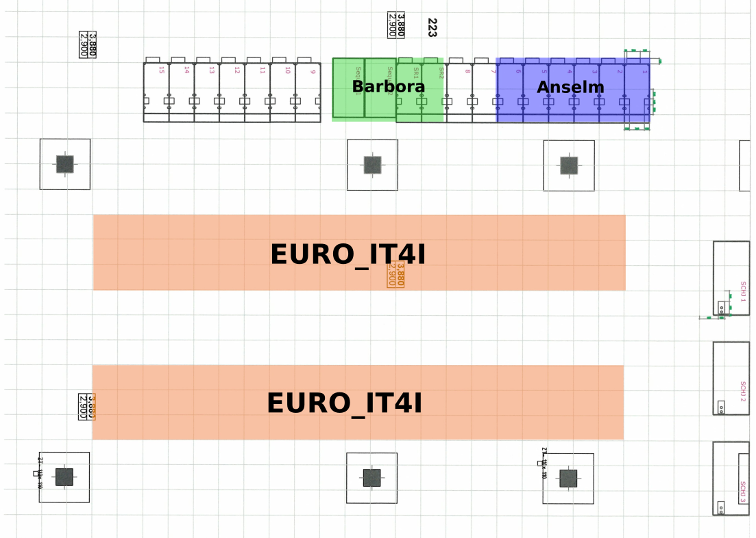
Fig. 3 EURO_IT4I system placement

- The distance of the racks from obstacles (walls, columns, rows of other racks) and the way of installation of the devices in the racks must not obstruct delivery, installation, replacement, and service of all equipment.

- The placement of all installed equipment of the delivered solution must not obstruct revision of electrical installation, cooling distribution, air-conditioning, and security systems (sensors, etc.).

- Rack installation on data center floor must be stable and safe. Rack weight must be suitably distributed. Floor construction and maximum load capacity (25kN/m2) must be observed. In case the installation applies point load or excessive load on a small area, load spreader must be used. Floor tiles modifications (penetrations to the raised floor area) must be carried out in a way that does not reduce the tile‘s load capacity. Adjustment of the floor tiles must be carried out by the contracting authority’s contractor providing the data center services.

- Cabling (inside and outside the racks) must provide reliable connection, handling of equipment (e.g. when servicing the equipment), and prevent damage to the cables during handling. Penetrations to the raised floor area must be fitted with grommets.

- (I) In the offer, the supplier must provide a schema illustrating the proposed EURO_IT4I system placement in the contracting authority’s data center.

Requirements – Power Supply
- EURO_IT4I system power supply and operation solution must respect the contracting authority’s constraints, specifically power circuits parameters.

- EURO_IT4I system will be supplied simultaneously from independent data center power supply branches (A and B).

- Failure or outage of power circuit or power supply branch must not damage any equipment and must not cause danger to persons or property.

- Failure or outage of any single power circuit or power supply branch must not cause:
- Inaccessibility or outage of supercomputer services, with the exception of Universal and Accelerated compute nodes services
- Inaccessibility or outage of Compute network services
- Inaccessibility of more than 67% of Universal compute nodes
- Inaccessibility of more than 67% of Accelerated compute nodes
After the restoration of power circuit or power supply branch, the power redundancy of all devices must be ensured automatically.
The ATS switch solution can be used only for LAN and Compute network switches power supply. In case the solution implements the ATS switch, the switch must provide remote management.

- EURO_IT4I system must be designed in such a way that under standard/even load of ICT systems the supply branches and individual phases of the power supply are under approximately even load.

- The solution must take into account the maximum input power for operation of all supplied equipment.

- EURO_IT4I system must allow the entire system to be shut down. Proper EURO_IT4I system shutdown must take 60 minutes, at a maximum.

- (I) In the offer, the supplier must include the energy calculation which must specify:
- Maximum electrical power consumption of the whole solution
- Electrical power consumption of each rack or stand-alone equipment

- (I) In the offer, the supplier must provide a schema and parameters of EURO_IT4I system connection to data center power circuit.

Requirements – Cooling
- EURO_IT4I system cooling and operation solution must respect the contracting authority’s constraints, specifically data center cooling system parameters.

- The solution must be thermally neutral to the data room. The solution must provide cooling of all heat released by EURO_IT4I system equipment.

- As the cooling source, EURO_IT4I system must only use water cooling circuits (cold and hot water circuits) of the data center.

- EURO_IT4I system cooling will be supplied simultaneously from independent data center water cooling circuits.
For cold water cooling, circuits SV1 and SV3 must be used simultaneously.
For hot water cooling, circuits TV1 and TV2 must be used simultaneously.
These circuits are considered the primary ones. Internal cooling loops of the supplier’s equipment (e.g. CDU) are considered the secondary ones.

- Failure or outage of the cooling circuits must not damage any equipment and must not cause danger to persons or property.

- Failure or outage of any single data center cooling circuit must not cause inaccessibility or outage of supercomputer services.

- EURO_IT4I system must be designed in such a way that under standard/even load of ICT systems the cold water cooling circuits are under approximately even load.

If EURO_IT4I system needs more than 300 kW of cooling capacity from the hot water cooling circuits (TV1 and TV2) then it must utilize both hot water cooling circuits and cooling must be designed in such a way that under standard/even load of ICT systems the hot water cooling circuits are under approximately even load.
The even distribution of the cooling is preferred by logical units, e.g. compute partitions where one circuit would serve as main for Accelerated compute partition and the other as main for Universal compute partition.
If EURO_IT4I system needs less than 300 kW of cooling capacity from the hot water cooling circuits (TV1 and TV2) then the distribution of the load between the two circuits is not required.
The fulfillment of the requirement regarding even load must not be based on alternating/switching of cooling circuits.

- Universal partition must use the hot water cooling circuits (TV1 and TV2) as prevailing source of cooling and must use direct liquid cooling. Universal partition must be fully operational with primary hot cooling circuits temperature set at any value in range of 30°C to 32°C.

- Each connection of EURO_IT4I system cooling to the primary cooling circuits must allow individual remotely controlled switching between two primary cooling circuits (see SPEC_336 for details). (For the avoidance of doubt - such a connection can be used for cooling of several devices/racks.)
Switching between the primary cooling circuits must take 3 minutes, at the maximum. Switching must not cause inaccessibility or outage of EURO_IT4I system services and must not damage any equipment in the data center. Circuit switching must not cause undesired primary circuits connections.
Remotely controlled cooling circuits switching will be integrated into the contracting authority’s Measurement and regulation system (MaR). The integration will be performed by the contracting authority in cooperation with the supplier. The solution must be compatible with MP-Bus technology, it must provide an MP-Bus interface and act as an MP-Bus Slave device controlled by MaR MP-Bus Master.

- In case of risk of exceeding the maximum operating temperature of the equipment or components of the equipment (e.g. in case of failure of the source cooling circuit), the affected equipment must be shut down automatically and immediately to eliminate the risk of overheating or damaging the equipment or components.

- (I) In the offer, the supplier must describe the cooling solution of EURO_IT4I system. Specifically, the supplier must provide information about the cooling of Universal partition, Accelerated partition and other compute partitions and systems, about cooling load distribution, and about cooling circuits switching.

- (I) In the offer, the supplier must provide a schema and parameters of EURO_IT4I system connections to the data center cooling circuits.

Requirements – Transport
- During equipment transport and installation, the load-bearing capacity of the floor on transport route must not be exceeded.
The load-bearing capacity of the floor in the data center and its access corridor (room 219 and 223) is 25kN/m2.
The load-bearing capacity of the floor in the access area (room 217 and 218) is 5kN/m2. For the transport of material, the supplier must temporarily install load distribution plates (e.g. plywood panels) in this area, so that the resulting load of the floor during the physical delivery does not exceed 5kN/m2 and thus prevent floor damage.

Implementation and Further Actions

Implementation
- A part of the delivery must be a comprehensive implementation of EURO_IT4I system so that all the contracting authority’s requirements are met.

- The delivery must include design, delivery, installation, implementation, configuration, debugging, testing of all systems, and performance of acceptance tests.

Training
- A part of the delivery must be training in the scope and detail sufficient to acquire the knowledge necessary for the independent operation and administration of EURO_IT4I system.

- The training must provide the information necessary to understand the internal functioning of the systems, hardware, and software. The training must include a thorough introduction to operating procedures and administration of EURO_IT4I system.

- Duration of the training must be 25 hours, at a minimum. The number of participants must not be limited to less than 16 participants.

- The training must include introduction to management framework/tools, practical demonstration and work with the real system. Fully implemented and accepted EURO_IT4I system must be used for demonstrations.

- Trainers must be skilled professionals. The training must be in Czech or English.

- The supplier must provide the teaching materials and presentations in English.

- The schedule and detailed plan of the training must be produced in cooperation with the contracting authority’s project manager.

- The training must take place in the contracting authority‘s premises. For this purpose a conference room will be provided free of charge.

- (I) In the offer, the supplier must include the frame schedule and content of the training.

Documentation
- The supplier must provide a comprehensive documentation of EURO_IT4I system.

- EURO_IT4I system documentation must comprehensively cover all supplied systems and must by logically structured. The documentation must include the documentation of the actual state of the system and documentation of operation procedures (operating manuals). The documentation must describe all specific (custom) modifications (settings, functionalities, etc.).

- The documentation must also cover processes and procedures for system administration, regular maintenance, emergency management, and recovery.

- The documentation must also include English documentation (datasheets/spec sheets, manuals, administrator, and user guides) of delivered hardware and software. Documentation must be provided in electronic form, allowing text copying.

Benchmarking support
- The supplier must provide expert support for the benchmarking of the system. The optimization of benchmark performance, rule conforming execution and the submission of the results to the official lists will be performed by the supplier. The contracting authority intends to include the system in the following lists benchmarking:
  - Top500, HPCG, Graph500
    - Universal Partition
    - Accelerated Partition
    - Data Analytics Partition
  - Green500
    - Universal Partition
    - Accelerated Partition
  - IO500
    - Universal Partition
    - Accelerated Partition
  - MLPerf
    - Accelerated Partition

EC Declaration of Conformity
- All delivered systems and equipment must be accompanied by EC declaration of conformity.

Waste Disposal
- A part of the delivery is the disposal of waste produced by implementation of the delivery.
The contracting authority is not obligated to store packaging and packaging material and will not do so.

Warranty and Services
The system must have warranty and be serviced for 5 years.

There are mandatory requirements for the ticketing system used for warranty and support as well for the implementation phase of the system (installation): Full history of tickets processed, REST API functionality to create, update, and close the tickets, download full history of tickets including all details, metadata, and attachments. If the requirement for the specified support ticketing system prevents you to offer a complete EURO_IT4I system please state it explicitly.

Content Requirements of the Technical Solution Proposal
EURO_IT4I system technical solution proposal must include:
- the detailed description of EURO_IT4I system architecture
- proposed technologies
- functionality and properties of the solution
- the number of equipment and their configuration
- the number of licenses and names of software
- the means of meeting contracting authority’s requirements

EURO_IT4I system technical solution proposal must be provided in an electronic form, allowing text copying.

The license terms will be added in the relevant annex to the binding model contract.

Contracting Authority Infrastructure
EURO_IT4I system will be installed and operated in the data room of the contracting authority’s data center in the IT4Innovations building. The IT4Innovations building is located on the campus of the Technical University of Ostrava, Studentská 6231/1B, 708 00 Ostrava-Poruba.

Existing systems of the contracting authority are located in the data room.

Values mentioned in this section are indicative, real values may slightly vary based on various conditions (e.g. measurement accuracy, operating conditions, environmental conditions, etc.).

Data Center Dispositions
The data center is located on the second floor of the IT4Innovations building (room no. 223). The data center dimensions are 24.97 x 20.47 meters (511.1 square meters) with the clear height of 4.5 meters. The hall is designed as a separate, structurally undivided space.

Data room floor is systemic, antistatic raised floor with a grid of 600x600mm tiles, with height of 980mm. Data room ceiling with a grid of 600x600mm is suspended 700mm under the standard ceiling. The clear height between the systemic floor and the suspended ceiling is 2.9m.

Floor
Raised floor height: 980 mm – systemic solution. Load capacity limit 2,500 kg/m2 (25.0 kN/m2).

Frame construction made of steel "C" profiles in 600x600 mm grid. The support posts consist of height-adjusted posts with adjustable head. The columns and horizontal frames are connected by a fixed screw connection.

Floor tiles are made of mineral-based core; fire reaction class according to EN 13501 A2.
On the bottom of the tile is an AL foil. The sides of the tiles have plastic edges. The upper side of the tiles have a PVC layer. The surface is anti-static.

Suspended Ceiling
Below the building ceiling, there is a suspended metal ceiling made of galvanized steel 600x600x33mm, beveled edge 3mm; fitted into the hidden structure; smooth surface without perforation; UV-stable, electrostatically applied polyester varnish. Inspection cartridges supplemented with clips for tilting the cartridges down according to the suspended ceiling layout. A demounting tool is required to access the ceiling area.
Concealed hanging metal construction with U-profile and perpendicular DP-profile suspended by threaded rods.

Power Supply
Main Power Branch:
Topology: two independent power branches, 1+1 redundancy
Distribution system NN: 400/230V; 3+N+PE; 50Hz; TN-S
Distribution busbars:
Number of distribution busbars: 5pcs for each power branch
Distribution system rated current: 800A
Distribution busbars power supply system: TN-S 3x400/230V 50Hz
Distribution busbar rated power: 552kVA
Distribution system location: under raised floor
Distribution system connection method: PDB switchboard
PDB switchboard outlets specification 6x3f/32A; different configuration possible;
protection: fuse with gG characteristics
IT technology connection method: IEC60309 industrial sockets
The connection points are equipped with the 3f/32A configuration and are fitted with PKY32G435 sockets. In case a different configuration of PDB switchboard outlets is required, such PDB switchboards are a part of the delivery.

Cooling
Data center cooling is provided by five separate coolant circuits – two hot-water circuits and three cold-water circuits.

Under the data center raised floor, there are three branches drawn from each of the five cooling circuits. Branches are fitted with DN65 dry disconnect couplings. The branches are located under the floor of the data center and are accessible after removing some of the floor tiles. Circuits use a mixture of 35% propylene glycol and 65% water.

Basic parameters of cooling circuits, including connection data; given values are set-points (i.e. desired or target values of MaR system), real values vary based on operating conditions:
TV1 – hot-water circuit – red:
- End fittings: Victaulic UK 76,1
- Working pressure: 4.5bar
- data center differential pressure: 50kPa
- Flow rate: 40m3/hour
- Coolant inlet temperature: 30-32°C
TV2 – hot-water circuit – yellow:
- End fittings: Victaulic UK 76,1
- Working pressure: 4.5bar
- data center differential pressure: 50kPa
- Flow rate: 40m3/hour
- Coolant inlet temperature: 30-32°C
SV1 – cold-water circuit – green:
- End fittings: Victaulic UK 76,1
- Working pressure: 4.5bar
- data center differential pressure: 100kPa
- Flow rate: 20m3/hour
- Coolant inlet temperature: 11.5°C
SV2 – cold-water circuit – blue:
- End fittings: Victaulic UK 76,1
- Working pressure: 4.5bar
- data center differential pressure: 100kPa
- Flow rate: 20m3/hour
- Coolant inlet temperature: 11.5°C
SV3 – cold-water circuit – turquoise:
- End fittings: Victaulic UK 76,1
- Working pressure: 4.5bar
- data center differential pressure: 100kPa
- Flow rate: 20m3/hour
- Coolant inlet temperature: 11.5°C
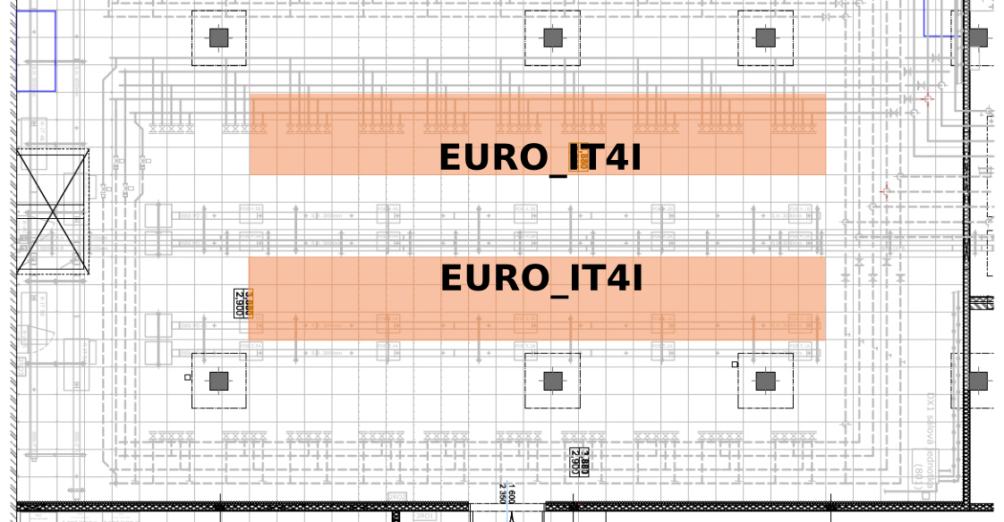
Fig. 4 Technology
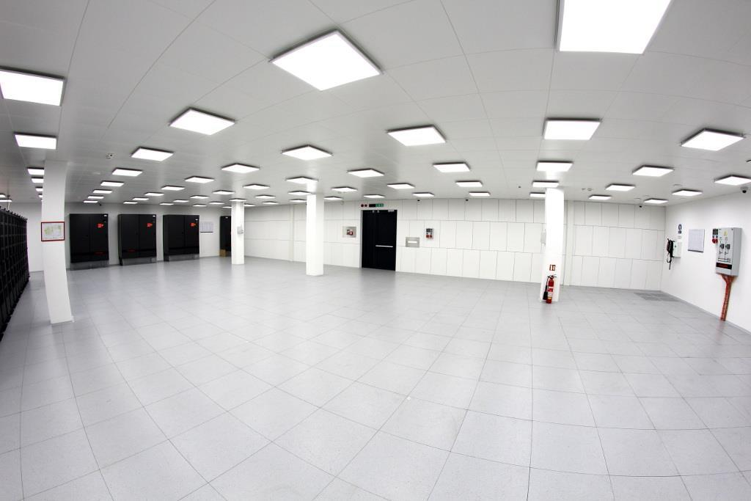
Fig. 5 Data room – space for EURO_IT4I system

Environment
Environment in the data room has the following conditions and parameters:
  - Ambient air temperature: 22°C to 25°C
  - Non-condensing moisture
  - Relative humidity: 20–60%
  - Hypoxic atmosphere, oxygen levels are decreased to 15 % vol. to prevent fire

Data Center Access Path
Equipment required for implementing the solution can be transported in the data center using the loading dock located in the northeast part of the building. The loading dock is 2850 mm wide and 1030 mm high.
For transportation, we recommend using trucks with lift gate. Room no. 218 is accessible from the loading dock area. Equipment with dimensions up to 2410x1540 mm (height x width) can be transported through the entry door leading to room 218.
Room 218 with dimensions of 5.3m x 5.6m can be used for the removal of transport packages or as a temporary storage during transportation.
Room 218 is connected to the data center by corridor (room 219). Rooms 218 and 219 are divided by door through which objects with dimensions up to 2340x1600 mm (height x width) can be transported. A part of this corridor’s floor, specifically a length of 8.5m, has a slope of 6.5° inclination
Entrance to the data center (room 223) is in the upper section of the access corridor. Equipment with dimensions up to 2360x1520 mm (height x width) can be transported through the data center entry door.
To fit through all three door, the equipment can have dimensions of 2340x1520mm (height x width), at a maximum.
The equipment can be transported to the data center via several routes, the only limitation are the dimensions of the door stated above.
The maximum floor load capacity in the access corridor (room 219) and the data center (room 223) is 2500 kg/m2 (25 kN/m2).

WAN/LAN Network
At the time of EURO_IT4I system implementation, the contracting authority’s current WAN/LAN network solution will be replaced with a new infrastructure for 100Gb/s Ethernet technology. Central devices of the new WAN/LAN will be L3 switches. The central devices will be structured as multichassis with common data plane and multichassis EtherChannel support or functionally identical technology. The central devices will have HSRP or VRRP technology. The central switches of the new WAN/LAN network will provide 4 ports equipped with QSFP-100G-SR4 modules with MPO-12 connectors for connecting EURO_IT4I system edge devices with the speed of 4x100Gb/s.

The location of the WAN rack and cable routes is illustrated below.
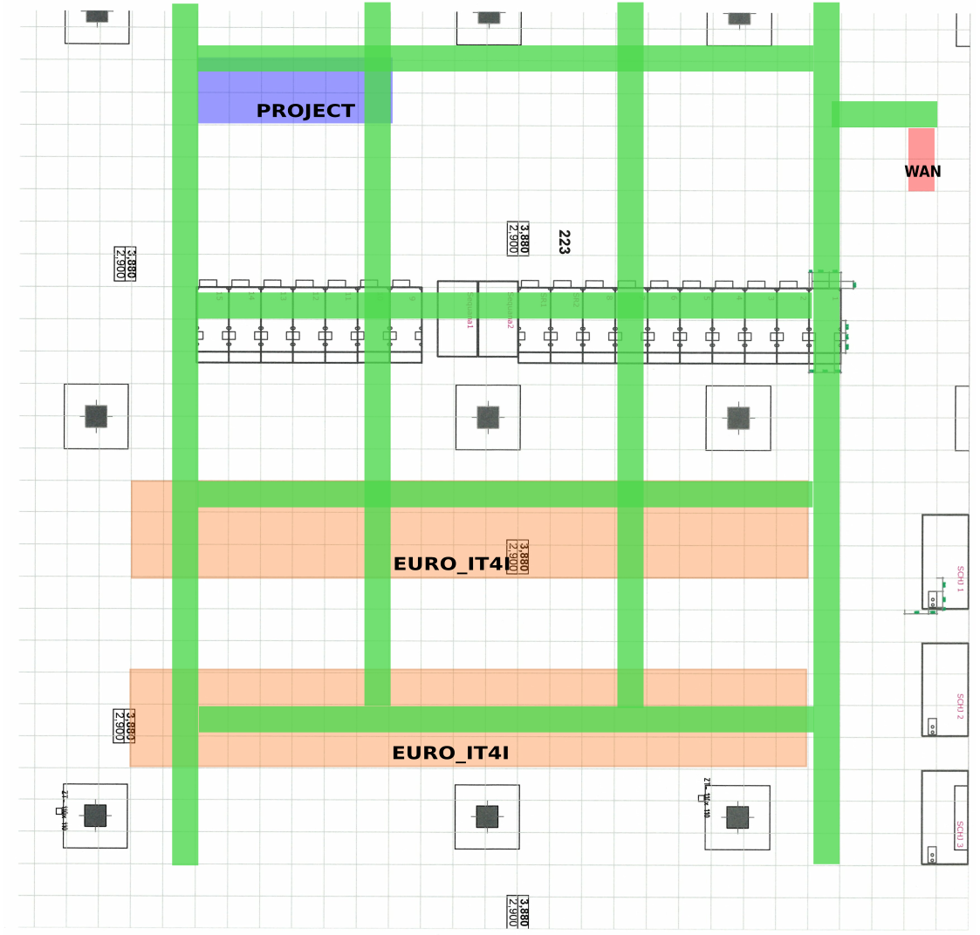
Fig. 6 WAN rack, cable routes

The specific type of central switches of the new WAN/LAN network is not yet known, because the procurement of these devices has not yet been fully realized.

OOB Network
The contracting authority’s current OOB network consists of:
- OOB router Cisco 2901/K9, console modules HWIC-16A (cables CAB-HD8-ASYNC)
- OOB switch Cisco WS-C3650-48TS, ports 10/100/1000BaseTX
- Cat6a patch panel with 24 RJ-45 ports, of which 12 ports are free
OOB devices are located in the WAN rack.

