Technical specification for LUMI-Q quantum computer system

Identification information of the Contracting Authority
Contracting Authority:
The European High-Performance Computing Joint Undertaking
Registered office: 12, Rue Guillaume J. Croll, L-1882 Luxembourg, Luxembourg,
The entity responsible for conducting the preliminary market consultation (hereinafter as “PMC”):
VSB-Technical University of Ostrava
IT4Innovations National Supercomputing Center
Registered office: Studentská 6231/1B, 708 00 Ostrava, Czechia,
(hereinafter referred to as “IT4Innovations”)
Contact person: Ing. Jan Juřena, tel.: + 420 597 329 579, e-mail: quantum-computer@it4i.cz
(please give priority to e-mail communication – emails are received by a group of interested persons)

Executive summary
Scope of the subsequent public procurement is an acquisition of a quantum computer for the LUMI-Q project. This computing system is a complex of quantum processing unit (QPU), cryostat refrigeration system, cryogenic connectivity and electronics, room temperature pulsed microwave electronics for the quantum processor operation, auxiliary servers (for circuit optimisation, control, API operation, etc.) along with appropriate storage, network elements together with software equipment and other components needed for an effective operation. The Contracting Authority expects the usage of the latest and most modern technologies for all used components at the time of delivery and a complex setup of all components including the software part to enable provision of advanced quantum computing workloads and quantum experiments. Part of the future subject of performance is also the delivery of implementation services, integration into the power and cooling infrastructure of the place of performance (i.e. IT4Innovations National Supercomputing center), training of staff, warranty and support services provision.
The Contracting Authority requires a QPU featuring at least 12 superconducting technology qubits in a star-shape topology, capable of both gate and pulse level control.
In the result, the LUMI-Q quantum system must allow for efficient, remote execution of quantum algorithm circuits via an appropriate API, using high-level frameworks and description languages (such as Cirq, Qiskit, and OpenQASM ), as well as quantum level experiments utilising pulse level of control.
A detailed site survey is offered to all interested parties (i.e. PMC participants/possible vendors etc.).
We ask the possible vendors to answer with a detailed technical proposal that satisfies the stated technical specifications as closely as possible.
All communication with PMC participants will be held separately, no information related to the technical designs themselves or the approach to the technical solution taken by the participants obtained within this PMC will be shared with third parties.

Technical features of the targeted quantum computer
The Technical features listed below reflect the Contracting Authority’s plans, visions and expectations based on its current level of technical understanding. All features should be understood as provisional and open for suggestions and changes, except when the word require(d) is used.
QPU architecture: We require superconducting qubit technology. Further, we require the QPU qubits interconnected in a one-to-all, star-shape topology. Figure 1 shows the connectivity diagram schematic. The central qubit is used to mediate an interaction with the remaining qubits via a swap (population-exchange) operation.
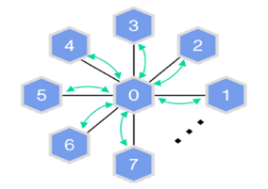
Figure 1. Connectivity diagram for the QPU with star-shape topology. The hexagons denote the qubits.
Each of the qubits should be probed with room-temperature microwave instrumentation for simultaneous frequency multiplexed readout. The expected readout and gate fidelities as well as relaxation times for the QPU are given in Table 1.
Table 1. Expected performance for the targeted QPU with star-shaped topology.
Number of qubits | At least 12 required, of which at least 10 fulfil the specifications below
Qubit connectivity | One-to-all in a star-shape topology
T1 relaxation time | average ~40 µs; minimum for all qubits:15 µs
T2* dephasing time | average ~20 µs; minimum for all qubits: 15 µs
Native single-qubit gate time | < 50 ns
Two-qubit gate time: CZ | < 120 ns
Single-qubit gate fidelity | > 99.7%
Two-qubit gate fidelity: CZ | > 99%
Readout fidelity | > 95%
System architecture and subsystems: The quantum computer should ship with a technology stack, from the quantum processing unit (QPU) into the software, enabling end-users to execute gate-based quantum algorithms. The hardware package should consist of the quantum processor, cryogenic connectivity, and electronics, as well as room temperature pulsed microwave electronics for the quantum processor operation. Further, it should contain auxiliary servers with adequate hardware configuration for circuit optimisation, control, API operation and similar tasks, along with appropriate storage. Active and passive network elements (routers, switches, cables) should be provided to cover both internal and external connectivity of the system. The control software should include a high-level interface with adapters for the execution of quantum algorithms defined with common description languages, as well as low-level operator/experimentalist access enabling direct scripted programming of pulsed microwave control sequences. The low-level access should also provide calibration access, and a wide range of scripts for common benchmarking techniques. The software stack should also include a quantum circuit optimiser, to transpile and optimise quantum circuits/algorithms to the native gateset and topology of the targeted QPU.
Control software: The system should include software stack covering at least operating systems for all equipment, firmware, drivers, monitoring, central logging, compilers/transpilers and others needed for the overall effective operation. If needed, appropriate licenses should be provided as well for 4 years.
The targeted quantum computer should be delivered with control software which enables APIs and execution control of quantum algorithms through high-level software interfaces. The software should also be capable of both supporting quantum computer calibration, as well as experimental R&D work.
The software should include low-level Python interfaces (for easy coupling to the rest of the deployed software stack) including the software drivers for room temperature electronics, as well as the framework for running control and readout sequences for testing the electronics and running basic quantum information experiments with a low-level source-code based approach.
A Python API should be included to enable rapid development of new quantum information experiments. The software suite should be based on a layered architecture which allows for higher levels of abstraction as well as providing low-level access to more hardware-specific interfaces. The software components should be deployed in a manner that provides production-level scalability, availability, flexibility, performance, and security.
High-abstraction level API: The quantum computer should be shipped with a set of software packages and services for executing quantum circuits on the quantum computer. It should allow users to define and run quantum algorithms on the quantum computer, expressed as quantum circuits using high-level frameworks and description languages such as Cirq, Qiskit, and OpenQASM 2.0.
Quantum circuit optimiser: The quantum computer should be shipped with a quantum circuit optimiser that allows users to transpile and optimise arbitrary (respecting the available number of qubits and allowed circuit depth of the quantum computer instance) quantum circuits to be compatible with the target QPU. Among other things, the optimiser should be able to express a given quantum circuit in terms of the native gateset of the quantum computer.
Quantum level experiments and pulse control: The quantum computer should be shipped with a software framework for the control, characterisation, and calibration of the quantum computer. Both low-level libraries for R&D and customisation on the instrument level as well as higher-level abstractions for performing quantum experiments in both pre-defined and ad hoc modes should be available. A software framework that enables end-users to develop applications that, e.g., (a) use predefined experiments to simplify the control and measurement process, (b) use automated procedures to eliminate repetitive operations, or (c) implement new experiments and automated procedures. An experiment entity should combine various functionalities such as execution flow, data manipulation, analytics, and presentation. It may also be built in a modular fashion making use of other experiments. The provided implementation of the experiment layer should include calibration experiments for single- and two-qubit gates and for qubit readout. Software for providing interfaces and implementations of control pulses and pulse sequences should also be provided.
Instrument drivers API: Instrument drivers for implementing the communication protocols API between higher-level software and the control instruments of the quantum computer should be provided. The drivers would encapsulate the technical details of initialisation, communication, and synchronisation of the instruments. The drivers should be based on an open-source framework, and be fully open and flexible: users should have the ability to improve existing drivers to provide additional functionality or develop a new set of drivers using the framework.
Control software database: The delivery of the control software should include a database installation which is a secure and reliable storage solution for all data produced by the experiments and for all the configuration information necessary for operating the quantum computer. The installation should include backups and monitoring for the database. The storage solution should provide the Contracting Authority with direct full read access to all stored data if needed.
QC system maturity / TLR at delivery: Despite the novel and unique qubit topology, the quantum computer is expected to have a TRL>8 (system complete and qualified) by the installation date, to ensure maximum uptime and accessibility for end-users.
Upgrade readiness: The system architecture and individual subsystems should be designed and sized such that the QPU upgrade is feasible after approximately two years of operation.

Environmental constraints
Installation Environment: The targeted quantum computer should be delivered as an independent assembly, with the physical characteristics and environmental tolerances summarised in Table 2:
Table 2. Physical constraints for the targeted quantum computer
Floor space | 25m² with a ceiling height of 3.2 metres. Includes the quantum computer and additional infrastructure and electronic equipment
Humidity | Humidity between 25 - 45% should be tolerated
Temperature | A room temperature stability of +/- 1 °C should be sufficient, around nominal room temperature 24 °C.
Electricity | 5-pin 3-phase 32A power sockets are available, from two independent power circuits A and B. All installed technology should be powered redundantly from A and B, utilising redundant power supplies or automatic transfer switches.
Environment | Raised floor and lowered ceiling is available, pass-through to the concrete floor or through lowered ceiling is permitted. Detailed site survey is available, see below. If additional environmental factors shielding is necessary, this must be installed and delivered as part of this procurement.
Cooling water | Chilled water outlets are available, T < 12 °C
Vibration | Up to 10 µm/s peak-to-peak spectrum amplitude for each of the axes at frequency range 1 mHz – 200 Hz
Electromagnetic noise | Up to 100 nT peak-to-peak spectrum amplitude for each of the axes at frequency range 1 mHz – 1000 Hz
Chemicals | Liquid nitrogen may be used on the data room
Other | Cryostat devices integrated into the delivered quantum computer.

Approximately 25m² of floor space is provided. The data room temperature is stable at 24°C. Electricity connections are provided in a 3-phase 6x32A configuration per power distribution box; these are easily reduced to 1-phase feeds when needed. Hygrometry of the room is automatically controlled by two automatic dehumidifier units. Coolant water at 10°C is available in the room via three independent cooling circuits. The computer room environment is not burdened by excessive vibrations, radiation or other external forces; the room is deep inside of the building, shielded from external influences. The computer room access routes, sensors and equipment adhere to the safety standards for handling liquid nitrogen.
Site survey: The Contracting Authority offers to all PMC participants a detailed site survey for the duration of up to 3 working days. The site survey may be used by the participant to assess the environmental conditions on the IT4Innovations data room. This may include placement and operation of instruments for the purpose of detailed measurements and assessment of local environmental conditions. The site survey should be booked at least 5 days in advance.

Planned LUMI-Q physical arrangements
The LUMI-Q quantum computer will be physically located on the IT4Innovations, VSB-TUO data room, next to the Karolina supercomputer. The floor space about 25m² in roughly a square floor plan is available, although other configurations are also possible. The LUMI-Q quantum computer should be integrated into the IT4Innovations data room including power, cooling and networking infrastructure. The IT4Innovations data room network integration is depicted in Figure 2:
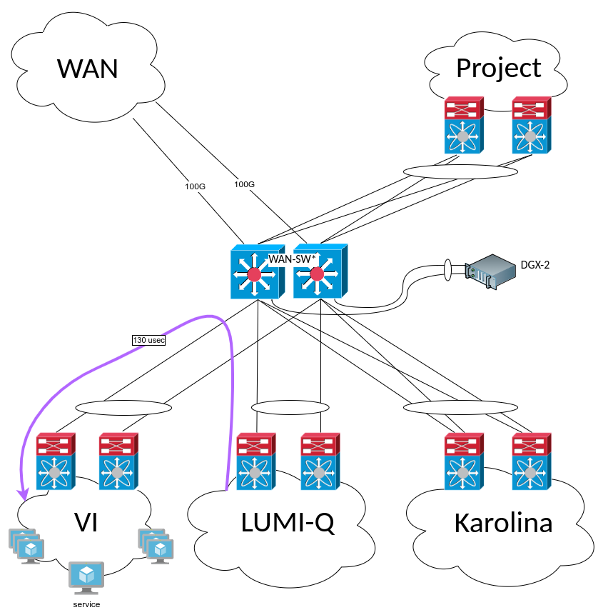
Figure 2. The LUMI-Q network integration at the IT4Innovations data room.

The proposed network interconnect ensures very low network latency in the microsecond regime (around 130 μsec, 250 μsec round trip time), high data throughput on the order of several GB per second, high availability and resiliency.

Policy and Legal aspects
The LUMI-Q quantum computer will be procured and owned by the EuroHPC JU. The EuroHPC JU shall cover up to 50 % of the acquisition costs, while the LUMI-Q consortium members cover the remaining acquisition costs.
Full warranty and support is required for the duration of 4 years.
The future vendor should commit to the KPIs outlined in Table 3.:
Table 3: Expected KPIs
No | KPI | Description | Target value
1. | Availability of the quantum computer | Fraction of time the system is fully usable (stable operation and delivering full performance) and available to users, meaning it processes the jobs and returns a result.  Quantum computer executes user operation, takes input from the user API and returns output. The fidelities and relaxation times are within the specified ranges.  Includes: calibration cycles, quality benchmarks subroutines. | > 75 % (monthly basis) for the first 3 months of operation  > 80 % (monthly basis) for the first 12 months of operation  >90% (monthly basis) for the remaining of the operational period
2. | Scheduled maintenance of the quantum computer | Maintenance is considered as scheduled if announced at least 1 week in advance.  Includes the replacement of chips and other components (if applicable) | Not more than 20 days per year  .
3. | Stability of performances of the quantum computer | Regular execution of a set of benchmarks e. g. on gate fidelity (if applicable)  Includes: successful calibration cycle and detection of quantum device degradation with time. | The specific performance target as be defined within the contract.

Response structure
In your response, please provide a detailed technical proposal containing full technical solution that satisfies the above technical specifications as closely as possible. In case of deviation, please propose and justify an alternate approach. Please follow the structure outlined below when appropriate:
- QPU Architecture and properties
- Cryostat system
- Cryogenic connectivity and Microwave electronics
- Auxiliary servers and storage
- Networking
- Software
  - Control Software
  - Control software database
  - Instrument drivers API
  - High-abstraction level API
  - Quantum circuit optimiser
  - Quantum level experiments and pulse control
- Legal and warranty
- Upgrade readiness
- Pricing of components
(include the table providing approximate split according to 1.-8.)
Component | Price (EUR)
- QPU
- Cryostat
- …..
- …..

